Artist Away: Procedural Generation of Terrain

Sam Connolly

19 April 2017

A project report submitted in partial fulfilment for the degree of

**Bachelor of Science in Computer Games Development**

**School of Physical Sciences and Computing**

**University of Central Lancashire**

Abstract

Currently throughout the modern-day games industry, artists are required to work alongside games developers to assist with the creation of models and levels. This presents problems throughout industry as artists and developers frequently have very different ideas about what is required from art assets and how they should be implemented. This project set out to find a balance between implementing realistic resources and efficient rendering of a scene. Currently this balance is rarely met due to difference of opinion between artists and developers. Constant battling between artists and developers can be a drain on company funds and with an increasing numbers of games development studios going bankrupt, companies are looking to avoid spending money where possible. One way in which this could be achieved is by having no requirement to hire an artist to design levels.

Artist Away set out to generate a realistic looking terrain which could be used as a level of a game, without any planning going into the level beforehand. This would involve generating the shape of the level, applying textures to certain areas to represent a real-world terrain, creating entities such as trees and plants, presenting realistic day and night scenes, and finally presenting a body of water which runs underneath the level. These requirements form the core components of a terrain which can be used as a game level, and all can be generated without any requirement for an artist. Artist Away would do all of this, and could save a company the salary of an artist, and potentially keep that company in business.

Artist Away makes use of procedural generation by generating a height map, the engine then plots vertices accordingly with the provided height map, and decides which type of terrain area each vertex belongs to per the vertex’s relative height. The engine then textures the vertices with the appropriate texture depending on the area type, and then generates entities in each area. The engine then defines the vertices for a body of water, and positions it underneath the terrain, all properties of the water will be controlled through the engine. The body of water adds realism to the scene. Finally, day and night cycles are triggered through the engine class, it should simply perform a gradual change of the skybox colour which will represent a time of day in which the sun is at a different position.

Artist Away successfully uses Perlin Noise to generate a height map, the engine then loads in the generated height map through one of two interfaces, a pre-generated ‘.map’ file or a dynamic two-dimensional array of values. The engine is responsible for determining which vertex of the terrain belongs in which area, it then makes use of HLSL shaders to render the appropriate texture to each area of the terrain model. The engine also has a small change to generate a tree or plant in grass areas, and position them at a random rotation. Day and night cycles area achieved by changing the colour of the skybox. Water is created as a plane which sits underneath the terrain, and the properties of the water are controlled through the engine.

Attestation

I understand the nature of plagiarism, and I am aware of the University’s

policy on this.

I certify that this document reports original work by me during my University project.

**Signature**  *Sam Connolly*  **Date** 19th April 2017

Acknowledgements

Laurent Noel is my project supervisor and has helped with technical explanations of areas which I then went on to implement within my project.

ASSIMP model library is a third-party library which I used for the loading of models within my engine, while I have set up this library myself I have not implemented the core mechanics behind most model loading.

AntTweakBar is a third-party library which provides an interface for controlling things within my engine, while I have set up this library myself, I have not implemented the core mechanics behind drawing the tweak bar and responding to events in the tweak bar.

SFML is a third-party library which provides an interface to loading and playing of sounds. I have set up this library to work within my project, however I have not implemented the inner workings of any of this library.

3D Game Programming with DirectX 11 – Book by Frank Luna which heavily influenced my implementation of the game engine timer class. While my implementation is not identical, the structure of the timer is the same. Also, provided me with the methodology of implementing rain through the geometry shader within Prio Engine.

<http://www.rastertek.com> is a group of tutorials which supplied me with the structure for my Direct X 11 engine, while there are similarities between my classes and shaders, there are also a wide variety of differences.

<http://flafla2.github.io/2014/08/09/perlinnoise.html> provides a C# implementation of improved Perlin noise, and provides an explanation for the process. This has been adapted within my own code to implement Perlin noise.

Table of Contents

Abstract i

Attestation iii

Acknowledgements iv

Table of Contents v

List of Figures ix

List of Tables x

List of Listings xi

1 Introduction 1

1.1 Background and Context 1

1.2 Scope and Objectives 1

1.3 Achievements 1

1.4 Overview of Report 2

2 Literature Review 3

2.1 Introduction 3

2.2 Game Engine Structures 3

2.2.1 Class Hierarchy Based Engines 3

2.2.2 Component Based Engines 4

2.3 Procedural Generation 5

2.4 Graphics Pipeline 6

2.4.1 Input Assembler Stage 7

2.4.2 Vertex Shader Stage 7

2.4.3 Tessellation Stage 7

2.4.4 Geometry Shader Stage 7

2.4.5 Rasterizer Stage 7

2.4.6 Pixel Shader Stage 8

2.4.7 Output Merger Stage 8

2.5 Summary 8

3 Project Planning 9

3.1 Introduction 9

3.2 Methodology 9

3.2.1 Scheduling 9

3.2.2 Development Lifecycle 9

3.2.3 Testing Strategy 10

3.3 Requirements 11

3.3.1 Selecting a Game Engine and Framework 11

3.3.2 Creating a Game Engine 11

3.4 Potential Solutions 12

3.4.1 Implementation of a Class Hierarchy Based Engine 12

3.4.2 Procedural Generation 13

3.5 Tools and Techniques 13

3.6 Legal and Ethical Issues 15

3.6.1 Is It Ethical to Automate a Person’s Role? 15

3.6.2 Automation in Industry 15

3.6.3 Legal Use of Third Party Tools and Resources 16

3.7 Potential Technical Issues 16

3.8 Algorithms 16

3.9 Summary 17

4 Design 18

4.1 Introduction 18

4.2 Project Design 18

4.2.1 Game Engine Design 18

4.2.2 Procedural Generation 19

4.3 User Interface Design 19

4.3.1 Prio Engine 20

4.3.2 Artist Away 21

4.4 Summary 22

5 Prio Engine 23

5.1 Introduction 23

5.2 Timing 23

5.3 Layout 23

5.3.1 Build Structure 23

5.3.2 Usage 24

5.3.3 Debugging Tools 26

5.4 Framework and Libraries 26

5.4.1 Choice of Framework 26

5.4.2 AntTweakBar 27

5.4.3 ASSIMP 27

5.4.4 SFML 27

5.5 Cameras 28

5.5.1 Displaying 3D Models In 2D Space 28

5.6 Models 29

5.6.1 Predefined Models 29

5.6.2 Loading Models 30

5.6.3 Rendering Models 30

5.6.4 Terrain 30

5.6.5 Water 34

5.6.6 Foliage 35

5.6.7 Skybox 36

5.6.8 Texturing 37

5.6.9 Optimisations 39

5.7 Rendering Techniques 40

5.7.1 Lighting 40

5.7.2 Blending 41

5.7.3 Back Face Culling 42

5.8 UI Images 42

5.9 Particle Systems 43

5.9.1 Rain 43

5.9.2 Snow 43

5.10 Summary 44

6 Artist Away 45

6.1 Perlin Noise Generation 45

6.2 Creating and Exporting Height Maps 46

6.3 User Interface 46

6.3.1 Controlling the Game 46

6.3.2 AntTweakBar Usage 46

6.4 Concurrent Programming 47

6.4.1 Multithreading Noise Generation 47

6.4.2 Preventing Multithreading Issues 47

6.5 Updating Terrain During Run Time 48

6.5.1 Generating New Height Map 48

6.5.2 Updating Entities 48

7 Test Strategy 49

7.1 Introduction 49

7.2 Creating a Test Harness 49

7.3 Time Dedicated to Testing 49

7.4 Testing Prio Engine and Artist Away 50

7.4.1 Identifying Test Cases 50

7.4.2 Engine Testing 51

7.4.3 Procedural Generation Testing 52

7.5 Summary 52

8 Evaluation, Conclusions, and Future Work 53

8.1 Project Objectives 53

8.2 Applicability of Findings to the Commercial World 53

8.3 Evaluation 54

8.4 Conclusions 54

8.5 Future Work 55

8.6 Concluding Reflections 56

9 Bibliography 57

Appendix 1 – Project Gantt Chart 59

Appendix 2 – Engine Class Diagram 61

Appendix 3 – Test Cases 62

List of Figures

Figure 2‑1 Class Hierarchy Structure 4

Figure 2‑2 Entity Component Structure 5

Figure 2‑3 No Man's Sky Gameplay 5

Figure 2‑4 Direct3D 11 Graphics Pipeline (Microsoft, 2017) 6

Figure 3‑1 Overview of Prio Engine Class Diagram 12

Figure 3‑2 Artist Away Use Case Diagram 14

Figure 3‑3 Model Class Diagram Within Prio Engine 14

Figure 5‑1 Engine Class Properties 25

Figure 5‑2 Vertex Projection (Noel, 2017) 29

Figure 5‑3 Perlin Noise Based Terrain 32

Figure 5‑4 Reflection Camera 34

Figure 5‑5 Tri-planar Texture Mapping of Terrain 37

Figure 5‑6 Texturing Without Blending 38

Figure 5‑7 Artefacts on Textures 39

Figure 5‑8 Incorrect Blending Equation Artefacts 39

Figure 5‑9 Alpha Testing 41

Figure 5‑10 Alpha Blending 42

Figure 7‑1 Ten Minute Test Plan 51

Figure 9‑1 Engine Class Diagram 61

List of Tables

Table 1 - Gantt Chart 60

Table 2 – Memory Test Cases 62

Table 3 - Engine Test Cases 63

Table 4 - 3D Modelling Test Cases 65

Table 5 - Procedural Generation Test Cases 67

List of Listings

Listing 5‑1 Face Normal Calculation 32

# Introduction

## Background and Context

With the release of No Man’s Sky (Hello Games, 2016), procedural generation has become a trending topic in recent times. Procedural generation is the creation of an entity, these entities can range from small entities such as trees, to larger entities such as a game level. Artist Away attempted to tackle the challenge of procedurally generating a level without the requirement for an artist, in theory a programmer would be able to instruct the program to design a level and the remainder of work would be handled by the engine.

This presented a challenge; which engine would be most suited for a procedural generation project? While many engines would allow for procedurally generated worlds, few would provide any form of flexible framework. By creating a bespoke engine, it is ensured that procedural generation would be fully supported by the engine. To implement Artist Away, a Direct X 11 based engine named Prio Engine has been designed.

## Scope and Objectives

Prio Engine is designed to support generation of terrain, however there are other core mechanics which are warranted by a game engine such as mesh loading, model control, render management, debugging logs, image loading, text rendering, accepting user input and lighting. Prio Engine must also support procedural generation specific functions, such as the loading of height maps, plotting terrains, the ability to integrate with the Artist Away project. All the while, Prio Engine should be kept as a flexible Direct X 11 engine to serve as a useful tool for future projects.

Artist Away on the other hand serves the purpose of creating height maps through noise algorithms, and must export the height maps in a format which Prio Engine can load. The ongoing integration between the two projects is crucial to success of this project.

## Achievements

I have successfully created a Direct X 11 Engine, which can be exported as a static library, and from the static library can be used to load, control and manipulate models. The engine can also accept height maps in one of two forms, a two-dimensional array, or a text file (exported from the Artist Away project) and from these height maps, procedurally generate terrain. The terrain is successfully textured using different textures per area, and a smooth blend is used between each of the textures. The engine defines a body of water, and successfully refracts the terrain tiling beneath the water.

I have also created a C++ program called Artist Away which uses Prio Engine as a static library, and can interface successfully with the engine to draw terrains, and supply the engine with height maps which are generated through Perlin Noise. Artist Away can also export ‘.map’ files which can be loaded using Prio Engine, as well as 2 dimensional arrays.

## Overview of Report

Chapter 1 presents an introduction to issues regarding level designers and introduces the concept of procedural generation as an alternative solution to employing a level designer.

Chapter 2 investigates the existing work surrounding both game engines and procedural generation within games.

Chapter 3 details the plan of investigation and development required to fully complete the project.

Chapter 4 outlines the design of how to set about completing the project, this involves structure and interaction throughout the project.

Chapter 5 details the implementation of Prio Engine as a Direct X 11 game engine, and outlines methodologies used within the engine.

Chapter 6 covers the implementation of Artist Away to procedurally generate terrain environments and the implementation of a noise algorithm.

Chapter 7 investigates possible approaches towards testing, and how testing was conducted within Prio Engine and Artist Away.

Chapter 8 reflects upon the project development, suggests alternate changes for the future, and what could have been changed to improve the development process.

# Literature Review

## Introduction

The first concept of a game engine was introduced with Doom (id Software, 1993), which presented a method of separating the game code from the resources used within the game. Over the years, the core concept of game engines has generally remained the same, however through advances in technology and modern day hardware, we are able to make use of much larger resources which can contain much more detail and as a result enables us to render higher detailed scenes to users.

Procedural generation is the technique of generating content in real time, which enables unique results to be generated each time a program is run. Caves and landscape features have previously been generated on the graphics processing unit with great success (GPU) (Mark, et al., 2015), Prio Engine and Artist Away explore an alternative method of procedural generation which creates content on the Central Processing Unit (CPU).

This chapter discusses existing uses of modern day game engines and explores the uses of procedural generation within games in the 21st century.

## Game Engine Structures

It was earlier established in section 2.1 that game engines are responsible for separating the resources and control of the game, however this is no simple task. Game engines are responsible for management of all resources, but are also responsible for the control, rendering and physics of all elements within the world. Throughout this section various options for interaction and communication with modern day game engines will be discussed, followed by the applicability to the project.

### Class Hierarchy Based Engines

Class hierarchy structures are found throughout a wide range of industry software. Class hierarchies are typically found in object oriented programming due to the representation of real world objects within classes. However, Pereira, et al. (2013) explains that as a hierarchy grows larger it grows more difficult to maintain. This proves to be problematic during development of game engines, as flexibility is of the utmost importance and as a result, classes can be added at any point in time which results in a rapidly expanding hierarchy. Figure 2-1 demonstrates a real-world implementation of a class hierarchy.



Figure 2‑1 Class Hierarchy Structure

Despite the drawback of large networks of classes, class hierarchies are an incredibly effective design tool for games engines due to the constant ongoing communication amongst multiple classes per frame. The use of a class hierarchy ensures that objects only communicate with relevant instances of classes within their sub-hierarchy, and as a result reduces unnecessary coupling between classes.

Hierarchy based engines are reasonably flexible and can be extended to implement new features in a game. For example, a hierarchy based engine could be extended to implement a phone in a game through the structure shown in figure 2‑1, allowing the engine to classify phones and apply different behaviours for different classifications of phones.

A class hierarchy is a suitable structure for Prio Engine due to the simplistic layout of a classes which allow communication throughout the engine to be easily illustrated through UML diagrams.

### Component Based Engines

Component based engines operate in a very similar manner to hierarchal based engines, in fact most component based engines still make use of class hierarchies. What separates a component based engine from a standard hierarchal based engine is that a component based engine will define each world object as an entity, each entity will contain multiple components to help it display the properties of a real-world component. Figure 2‑2 Entity Component Structure demonstrates the use of components with a theoretical game entity. Component based engines provide flexibility to add and remove components, for example if a vehicle were to run out of fuel, the movement component could be taken away from the instance of the vehicle entity and the object would remain in the game.



Figure 2‑2 Entity Component Structure

## Procedural Generation

Procedural generation is often found in games when there is a requirement for a unique experience for each player, as a wide variety of both graphical and gameplay elements can be generated without any added input from a developer or artist. A wide variety of content can be procedurally generated such as levels, adventures, characters, weapons planets, and plants (Julian, et al., 2013). Procedural generation has very few limitations within games, in theory entire games can be procedurally generated, as demonstrated in No Man’s Sky where levels, enemies and universes are generated in real time resulting in never ending game play and a unique game experiences for each player.

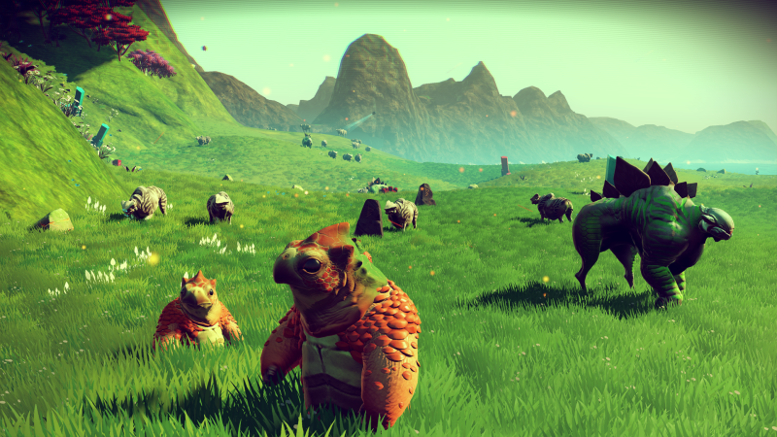

Figure 2‑3 No Man's Sky Gameplay

Procedural generation is typically processed through artificial intelligence (AI) methods within the field of computer science. Procedurally generating terrain allows users to experience varying levels, and tailor the gameplay experience to each individual user. To procedurally generate terrain a height map is required, these are typically calculated through noise algorithms, with Perlin noise being a popular choice due to its smooth transitions between values. The height map is then used to plot points in a grid formation at various heights, a common method of generation is to analyse the height of each vertex on the terrain, and dictate which texture should be applied to that area. However, a more effective approach is to separate the terrain into tiles before analysing each tile, and giving each tile a weighted chance to either be the same as the surrounding tiles, or change into a new tile. The latter method improves the realism as changes are not uniform throughout the world, resulting in a terrain which is a more thorough representative of that in the real world.

## Graphics Pipeline

The graphics pipeline is the render process from start to finish within frameworks such as Direct X, the graphics pipeline has changed slightly over the years with the introduction of geometry shaders and tessellation, however it has remained the same throughout Direct3D 11 and 12.

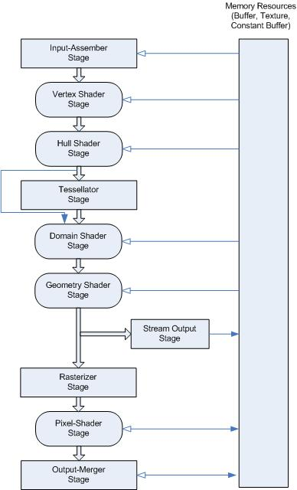

Figure 2‑4 Direct3D 11 Graphics Pipeline (Microsoft, 2017)

Throughout this chapter, areas of the graphics pipeline displayed in figure 2‑4 will be explained in detail, as this is the pipeline which will be used to render entities within Prio Engine.

### Input Assembler Stage

The input assembler stage is responsible for placing primitive data from buffers defined by the programmer onto the render pipeline and assembling the data into primitives which the remaining stages of the graphics pipeline will make use of (Microsoft, 2017). This is most commonly a triangle list, however triangle strips can be used for a minor performance benefit. An alternative to triangle lists are line lists, these are commonly found in particle systems for rain and snow (Luna, 2012).

### Vertex Shader Stage

The vertex shader stage is responsible for performing per vertex operations, and always outputs a single vertex. If the vertex shader fails or is inactive, then the pipeline will be unsuccessful. Vertex shaders are run on all vertices placed on the graphics pipeline in the input assembler stage.

### Tessellation Stage

The tessellation stage is only found in Direct X 11 and above, it supports creating new geometry from existing geometry, this helps to improve the detail within models. The use of a tessellation stage ensures that tessellation geometry is calculated on the GPU, and as a result is incredibly efficient in comparison to generating geometry within the software on the CPU.

### Geometry Shader Stage

The geometry shader stage takes vertices as inputs which form a primitive, and outputs a whole shape which we would otherwise create through vertex and pixel shaders. The output of the geometry shader is fed into the rasterizer stage which adds colour to the shape which has been produced. Geometry shaders are incredibly popular with particle systems as it enables many particles to be rendered by the GPU at very little cost.

### Rasterizer Stage

The rasterizer stage is responsible for creating images from the primitives passed in from the previous stages. Each primitive is converted into pixels, and mapped to the viewport in 2D space. The rasterizer stage is then responsible for determining how to invoke the pixel shader, and removes vertices outside the frustum to avoid them being rendered unnecessarily.

### Pixel Shader Stage

The pixel shader stage is responsible for colouring primitive shapes passed in from the rasterizer stage. Many techniques can be applied through the pixel shader to improve the visual appearance of models displayed on the screen, for example per pixel lighting provides a great aesthetic boost to scenes within games. A depth stencil occurs within the pixel shader stage to avoid overwriting the colour of pixels when a vertex is located behind another vertex in world space, however this can be disabled where necessary.

### Output Merger Stage

The final stage of the graphics pipeline is the output merger stage, this stage is responsible for calculating the final colour of each pixel on a viewport by combining the data generated in the pixel shader stage. It is the final step and will determine which pixels should be visible and as a result, which colour should be selected.

## Summary

A game engine is effectively a tool to assist programmers with the rendering of elements and management of resources, while there are choices as to how a game engine can be built, all structures are complex and each project is suited to an engine structure (hierarchical or component based).

Procedural generation provides unlimited opportunities to drastically improve replayability value to games, and provide a unique game experience to each player. The value of procedural generation has been explored in modern day games, and is frequently used in large games within the industry.

# Project Planning

## Introduction

Writing a game engine is no small task, it requires a large amount of planning. Writing an engine which is to be flexible enough to be used by other applications in future complicates matters further. By planning the structure of how applications will interface with an engine, we can reduce unforeseen errors encountered when using the engine over a variety of applications. This enables development of Prio Engine to be flexible and account for how the engine will be updated in the future, and how each change will affect programs currently using Prio Engine.

## Methodology

Planning is an incredibly important aspect of every project, the method which is selected to plan a project can determine the success of the plan itself. Throughout this section, an outline of the project plan, the reasoning of any planning and the methodology in which the plan will be followed will be outlined.

### Scheduling

Before commencing development, it can be incredibly useful to schedule out the project. This allows for iteration deadlines which aid with an agile development lifecycle, and helps to scope the project to analyse what elements were to be completed or omitted. Gantt charts are effective at planning, scheduling and tracking progress of a project, however they are most suited for brief overviews of projects. A Gantt chart was created for the project (appendix 1) as according to Wilson (2003) they are effective at displaying a quick overview of tasks, highlighting issues where work was scheduled but failed to be delivered, and allowing the developer to remedy the situation. It was made apparent throughout the development process that the Gantt chart could not serve as a hard rule which development would stick to due to its conflict with agile methodologies and the inability to accurately predict a development period in the future, however it still served as an estimation of where development should be at any point in time.

### Development Lifecycle

An agile approach was selected for Prio Engine since the overall project in fact consists of two separate sub projects. By adopting an agile development lifecycle, Prio Engine can run independently from Artist Away, and can be used with a wide variety of other projects.

Prio Engine consists of many components, and as such both the design and development are required to be as flexible as possible. It is well renowned how fragile IT systems can be if they are not developed in an agile manner (Jacobson, et al., 2016). Developing Prio Engine in an agile format enables the developers to support a wide range of unknown applications in future. However, development of Prio Engine could not be completely agile, as there is a time constraint in the form of the project deadline. This resulted in practicing certain agile methodologies while leaving out others. One agile methodology which enabled planning of Prio Engine was the use of tasks, stories, hills, and epics. A task is a small task, a story consists of many tasks to complete a larger challenge, a hill may have many stories and often refers to a project, and an epic is the combination of these and describes the product in its entirety. The use of tasks within Prio Engine allowed the developer to break up the required work into much smaller tasks, developers can then place importance and urgency on these tasks, and decide on a timescale for each task. This ensures that the crucial components of the engine are developed at the correct times.

The development of Artist Away while agile, was much smaller. This made it a simple development process where the developer could implement the core mechanics of Prio Engine, and then write the height map generation for Artist Away, furthermore Prio Engine could be adapted to accept this height map and the remainder of development and expansion could occur within Prio Engine.

### Testing Strategy

In an agile life cycle, development typically occurs in chunks and as a result so does testing. These chunks are known as iterations and are incredibly important to the success of continuous integration testing, as if the testing of an area is cut short the most important areas of each iteration can be prioritised to minimalize ineffective testing (Jiang & Chan, 2016).

In an ideal world, there would be a set of automated test cases which the engine must pass before progressing into the next iteration, however due to time constraints there is simply no available time for the developer to write a multitude of test cases. Instead, it proves more efficient for the developer to conduct manual test cases upon the engine and continuously test integration with Artist Away at the end of development in every iteration.

Bach (1998) outlines the methodology named ‘Good Enough Testing’ which is an alternative to exhaustive testing, and allows testers to determine when a solution has been deemed to pass testing. I believe ‘Good Enough Testing’ is both an important and effective methodology for the testing of Prio Engine and Artist Away, as the time constraints placed upon the project render exhaustive testing both impossible and ineffective. A period at the end of each iteration is dedicated to testing, with more important test cases prioritised. If minor bugs occur, the project will not be deemed to have failed testing, instead bug fixes will be placed on a development queue at low priority, if time allows towards the end of the project then bug fixing will occur.

## Requirements

### Selecting a Game Engine and Framework

The games industry provides are large list of existing engines to select from, however many of these engines prove not to be flexible enough and limit the scope of projects (Ali, 2016). Through careful planning, selected engines can be eliminated should they not meet the project requirements, however using an existing engine still prevents future flexibility of the project. Often in software development, there are requirements which go unforeseen at the start of a project, and later in the development lifecycle become more apparent. By creating a bespoke game engine, a project can be flexible in the future as the engine can be modify to suit project needs.

Direct X 11 has had overwhelming amounts of support from the development community since its release and has continued to thrive since the release of Direct X 12. This is primarily due to the complexity of Direct X 12 which makes it incredibly difficult to develop with, and is designed solely for experts. Microsoft recognised the complexity of Direct X 12, and released Direct X 11.3 in 2015 as a Direct X 12 alternative. As a result, Direct X 11 has continued to thrive throughout the release of Direct X 12, and has widely available support and resources, while supporting modern features such as geometric shading and tessellation.

Direct X 12 is also limited to Windows 10 platforms only. This drastically reduces the target market for any engine, and coupled with the complexity of development in Direct X 12, it does not make for a suitable choice of framework for Prio Engine. Direct X 11 has been selected as the development framework of choice in this project due to its superior support and simplicity in comparison to Direct X 12.

### Creating a Game Engine

Prio Engine must be able to load, control and render models at 60 frames per second when using the minimum specification graphics processing unit (GPU) which is an NVIDIA GTX 960. Model control is the core mechanic behind games engines, however it is useless if it cannot render at a smooth and realistic speed.

The engine must be able to be exported as an external library, this will enable other applications to use it. Furthermore, the engine must be able to generate terrain from a height map provided by another application. Another requirement from the engine is that it must be able to control model position, rotation and scale and render them correctly, outside of the engine, and without being exposed to the complexity of the engine.

The height map must be generated by Artist Away and be stored in a two-dimensional array or a ‘.map file’, the engine will be able to read either of these methods. Artist Away must make use of the Perlin Noise algorithm to smoothly generate a realistic looking terrain shape.

The complete project must generate terrain which reflects a real-world environment not just in shape, but in appearance too. The terrain should be decorated with a variety of entities which result in the terrain looking more realistic, and less bland.

## Potential Solutions

### Implementation of a Class Hierarchy Based Engine

To plan Prio Engine, I started with a diagram of how I expected the engine to look: 

Figure 3‑1 Overview of Prio Engine Class Diagram

At a glance, it appeared this was a reasonably flexible solution that would account for future changes. For example, should I wish to change the engine from running on Direct X to OpenGL, theoretically, I should only be required to change the Direct3D class. However, this isn’t quite the case as there are some differences between the types of buffers and how they are used in Direct X and OpenGL. It also demonstrates that we could use it as a static library by providing methods for users through the Engine class, and allow the engine itself to handle the inner workings through a network of classes.

Another potential solution which was considered was an entity based system which would control all entities within the scene throughout an entity based manager. Overall, this may have been the better choice, however I believed it would not have brought enough benefit for the overall purpose of this game engine which is procedural generation of terrain to warrant implementation, it would only provide benefits in flexibility for future use.

### Procedural Generation

Different types of generators can create drastically different content and result in two incredibly different levels. It can be difficult to recognize and evaluate the difference in procedural generators (Horn, et al., 2014) and therefore careful planning of how the content will be generated is incredibly important.

Perlin noise is a very popular choice of noise used for height maps. Since Ken Perlin’s release of his improved Perlin noise algorithm, there has been a boost in popularity for use of the algorithm with procedural generation of terrain. The new and improved algorithm improved the smoothness in the transition between noise values and enabled noise to be generated in three dimensions rather than being limited to two. By creating a custom Perlin noise implementation, it is ensured that the values generated are formatted correctly, and can be manipulated according to parameters which the user can define.

We can then allow Prio Engine to process the height map, create a terrain from the height map, and divide the terrain into areas according to their height in relevance to the rest of the terrain tiles. After dividing terrain tiles into areas, two things may occur; firstly, a relevant texture can be selected for that area, secondly, we can generate a chance to create an entity on that area of terrain. For example, a terrain tile may sit at 50% of the total height within the height map, the engine may decide this is a grass tile, the engine also then states each grass tile has a 5% chance to have a tree at this position. The engine can also analyse nearby tiles and take their properties into account, this analysis enables the procedural generation algorithm to determine whether or not entities such as trees, foliage or plants should be located on this tile.

## Tools and Techniques

GitHub was used as a tool for source control, it enabled modifications to be submit and the ability to roll back to previous versions of the code base for both Artist Away and Prio Engine.

AntTweakBar was used to give users of Artist Away control over select variables used throughout the application. The use case diagram below details how users can interact with Artist Away while it is running, and provide custom parameters to artist away.



Figure 3‑2 Artist Away Use Case Diagram

ASSIMP was used to load a wide variety of models in different file formats into the engine. It is used within Prio Engine by parsing information about meshes and loading in the relevant files, and storing this information in member variables, before passing it over to buffers to be used with HLSL shaders. The class diagram below is an overview of how the mesh loading process works within Prio Engine.



Figure 3‑3 Model Class Diagram Within Prio Engine

## Legal and Ethical Issues

### Is It Ethical to Automate a Person’s Role?

As technology becomes more complex, users of technology are required to adapt to the latest versions of technology. In some scenarios this is perfectly acceptable, however in the modern-day games industry with the expectations of developers constantly rising, small independent companies simply cannot afford to spend time training their artists to use the latest technology and present it in the format required, as well as simultaneously developing the code behind the game. There is also no guarantee on how long it will take an artist to create a resource, due to a lack of reliability caused by human errors. According to (Neumann, 2016), we will continue to face these issues as they are a by-product of human labour. Automating the artistic process would result in a more consistent product being produced, as it programmatically executes a process, and there are very few variables involved in the production methodology. Given independent games companies are typically not renowned for being particularly wealthy, and are renowned for shutting down due to a lack of funds before games are released, it seems illogical for smaller companies to risk hiring an artist to design levels, when a stable option of procedural generation can be used to complete the same process at no extra cost.

### Automation in Industry

As automation becomes increasingly popular and more attractive to employers, regulations and legislation regarding automation are being introduced. Unfortunately, we cannot predict what laws will be introduced in the future, however we can analyse the legislation introduced surrounding driverless cars, a popular form of automation. The Vehicle Technology and Aviation Bill imposed the idea that insurance companies which insured the automated vehicle would be responsible for reimbursing any damage caused by that vehicle. If we take similar logic and apply it to the process of procedural generation within games, we can rule out the requirement to pay damages as no insurance companies are involved, and no physical damage can come of a computer program which generates a game level. Because the company would be responsible for any mistakes within the game level, it would not matter if it were an artist or a computer program which designed the level.

While the legal side of automation is clearly not much of a barrier to the games development process, the ethical question remains: is it acceptable to remove an entire role from the industry to save money? There is no clear-cut answer to this question, and the answer is entirely situational and depends on the size, budget, and longevity of a games studio. This author believes it is only acceptable to automate a process when all other options have been exhausted, and it is simply deemed not feasible to hire an artist as a level designer. Business owners have a responsibility to provide careers to working class people, particularly larger business owners. This keeps the economy within the country stable, and provides workers with money to spend on business products.

### Legal Use of Third Party Tools and Resources

Prio Engine makes use of two third party libraries (AntTweakBar and ASSIMP), we firstly need to ensure that the licensing on these products allows for use within a final year project. AntTweakBar uses the zlib/libpng license, which claims the library is both free to use and redistribute, meaning that it is a completely eligible choice for use with Prio Engine and Artist Away. ASSIMP holds a 3 clause BSD license, the three clauses summarise to claim that the copyright notice must be displayed unmodified on binary and source files, and that ASSIMP cannot be used to endorse Prio Engine or Artist Away. Prio Engine can meet these conditions and therefore licensing of third party libraries has provided no issues.

To ensure there were no legal issues Prio Engine has exclusively used free to use and royalty free resources including textures and 3D models.

## Potential Technical Issues

The first issue I face is keeping the game engine separate from the height map generation, yet keeping procedural generation itself within the engine. My design research resulted in the model where Prio Engine is a static library, which is included within Artist Away. This enabled us to generate height maps in two dimensional arrays, and pass them to Prio Engine as two dimensional arrays, from which Prio Engine could procedurally generate terrain. However, it did not seem feasible for future use to tie the generation of terrain to Artist Away, so a method was placed into Artist Away to export ‘.map’ files, which were rows and columns of floating point numbers which represent a height map. After implementing the ability to import ‘.map’ files in Prio Engine, and place the extracted values into a two-dimensional array, we ended up with a method which meant Prio Engine could be run without any requirement for Artist Away, unless you wanted to modify the height map during runtime.

## Algorithms

Procedural generation can take many forms, but for an effective and smooth transition in height as is with terrain, some form of noise generation algorithm is required. (Mikuličić & Mihajlović, 2016) discuss the use of Perlin Noise to generate height maps, combined with Fractional Brownian Motion. This seems like a perfectly reasonable solution to generate height maps, however in 2001 Ken Perlin presented his improved version of Perlin Noise. According to (Perlin, 2002) the new improved Perlin noise algorithm is quicker to generate than the previous algorithm, and in theory could be expanded into multiple dimensions rather than just two. While development of Artist Away has very little interest in the multiple dimension aspect of Perlin Noise, improving the efficiency of generating height maps is an important part of development. Improved Perlin noise was chosen as the more appropriate algorithm to use within Artist Away, as there was very little change in the complexity of the algorithm and implementation was worthwhile given the performance benefits.

## Summary

The planning behind Prio Engine and Artist Away was a sufficiently thorough process, it covered a wide range of areas from the broad development methodologies through to class diagrams, however the most important aspect of the design process was the ability to adapt to new and changing requirements. This is due to not knowing what issues may occur throughout development, by maintaining a flexible outlook and not tying development to a strict plan, development structure is able to adapt to any problematic situation which may arise.

# Design

## Introduction

Prio Engine targets developers while Artist Away targets users of the game. Having two separate target audiences requires two separate design techniques, as Prio Engine is required to be somewhat complex, while Artist Away is required to be as simplistic and intuitive as possible.

Prio Engine and Artist Away are both written in C++ making use of object oriented methods to simplify how components within both projects interact with one another.

## Project Design

### Game Engine Design

(Gregory, 2012, pp. 11-12) defines a game engine as a piece of architecture in which the artistic resources are separated from the core components such as the rendering system, collision detection system or sound system. From this definition, we can interpret that users of the engine will be responsible for loading of resources, but not implementing the code behind it. This is applicable to our engine as a user may want to create a terrain height map as a resource, and have the engine load this. We accommodate for this feature by accepting a map file which simply contains the same information that would be contained in the two-dimensional array generated by Artist Away.

The first step to designing Prio Engine was to research game engine architectures which would enable Prio Engine to be flexible and run with a variety of projects. Continuing from architecture research, a class diagram was drawn up to help visualise interaction throughout the engine (Figure 1).

The next design choice was to move the engine components into a dynamically linked library (DLL) or static library. DLLs in Visual C++ (Microsoft, 2015) describes a DLL as an executable file with shared functions and libraries. Whereas static linking involves exporting code as objects, and importing the functions and code through library objects. While DLLs are more efficient in terms of file size as they only load the required functions into memory, it made more sense to use Prio Engine as a static library as there is a whole range of optimisations that could occur by the optimising compiler in release mode of visual studio, which developers would be completely unaware of. It was deemed the benefits of using the engine as a dynamically linked library simply did not outweigh the security of using the engine as a statically linked library.

### Procedural Generation

Procedural generation allows game content to be created within a game itself. This is beneficial to games developers as it means they are not concerned with the implementation of elements of the game itself, but rather the process of creating those elements. Once procedural generation is implemented, alternate game content can be generated on the fly.

Artist Away set out the target to investigate the use of procedural generation of terrain. This results in the content being generated the equivalent of a game level, rather than other forms of content such as story lines. A height map is required to generate terrain. Height maps are generated through noise algorithms.

#### Perlin Noise

The most popular noise algorithm used within procedural generation is Perlin noise due to the smooth transition between values generated. Improved Perlin noise (Perlin, 2002) has drastically increased the popularity of this algorithm, as it enabled noise to be created in three dimensions as opposed to being limited to two, and is also much faster to generate. Perlin noise has been selected as the algorithm of choice for Artist Away, due to its smooth transitioning traits.

#### Fractional Brownian Motion

Fractal Brownian Motion could theoretically be applied to noise values generated, this alters the noise value by applying a Gaussian function to the generated values. This would provide the illusion of smooth transitioning values. Fractional Brownian motion has not been selected for Artist Away, due to smooth transition of values already implemented within Perlin noise, however it does enable other noise generation values to be considered.

#### Image Noise

Image noise is a random noise, this is to say that there are no purposeful smooth transitions between the noise values. This would present a wide variety of heights within a height map, however would not correctly suit the requirement of a height map for terrain, as changes in the noise values would be too sudden. Combining this noise with fractional Brownian motion discussed in section 4.2.2.2 would help to smooth the transition, however it would involve more development time than simply implementing Perlin noise from the start.

## User Interface Design

Onal, et al. (2014) found user interface of a game can drastically impact the level at which a user will co-operate with a game, and can define the level of interest a user has for a game. As Prio Engine and Artist Away are split into two projects, two user interfaces must be defined. Prio Engine will be used by developers and therefore the engine class will be the interface, whereas Artist Away can be used by any none technical user, and as a result requires a more simplistic user interface.

### Prio Engine

Prio Engine is a code driven engine, and does not make use of scenes, demonstrated in larger engines such as Unity and Unreal Engine 4. The user interface for Prio Engine is designed for developers and not end users, as the engine is controlled through the engine class. The engine class may return certain elements such as a pointer to a mesh, so that the user can create models from this mesh, however for the most part the engine will oversee managing the scene and this will be hidden from the developer. Through the engine class interface, the developer will maintain the ability to initialise, shut down and get the time it took to process the last frame for the engine. These three parts of functionality are the core of Prio Engine; however, the developer will not have to implement everything they require the engine to do as a lot of functionality is already covered.

#### Predefined Shape Creation

Prio Engine makes use of predefining shapes such as cubes and triangles, they are incredibly useful when debugging code and requiring a model, instead of the programmer defining the vertices and adding render code, the ‘CreatePrimitive’ function is called from the engine class, and Prio Engine will handle the rendering of the predefined vertices. The vertices and indices are all defined in the ‘PrioEngine’ namespace, which can be found in ‘PrioEngineVars.h’. Users can also remove the shapes by a function named ‘RemovePrimitive’.

#### Terrain Creation

Terrain can be created and initialised through the engine class interface. Two methods exist which allow it to import a text file which contains heights where each element is separated by a space, and each row is separated by a new line. Terrain can also be imported through a two-dimensional array of type double. The terrain creation functions return a pointer to the terrain, so the user can modify the terrain elsewhere. The user also maintains the ability to update an existing terrain entity through the engine class.

#### Meshes

Meshes are loaded and destroyed through the engine class interface, the model creation for a mesh is done through the mesh object which is returned through the engine. By loading meshes through the engine, we can ensure that optimisation techniques through frustum culling are handled by the engine, and all models and meshes are rendered in the correct order.

#### 2D UI Images

Prio Engine also offers the ability to load in user interface images which will be rendered last, and therefore sit on top of everything else which is rendered in the window. These are particularly useful for showing UI elements like health, completion, and mana pools in a wide variety of games. The ability to create and remove these from the scene through the engine is an incredibly powerful tool to developers.

#### In Game Text

Prio Engine offers a method of displaying text in a game through Direct X 11, after the functionality was removed in Direct X 10, this can prove to be an incredibly time consuming feature to implement. It also allows text to be updated without having to destroy and recreate the text object, you must simply pass the new string you wish to display to the text object.

#### Skybox Environment

Developers can also update the skybox through Prio Engine to give a level a different feel. By default, the skybox will cycle through day, evening, and night times. However, developers can disable automatic cycling, change the time between cycles and select a specific colour they want the skybox to be.

### Artist Away

#### Ant Tweak Bar

AntTweakBar allows users to interact with the program and modify variables from within the executable during runtime. Prio Engine fully supports AntTweakBar usage, and demonstrates the use of AntTweakBar within Artist Away. Through AntTweakBar, users can modify the height map during run time, which also allows for a wider variety of terrains to be generated. Furthermore, the user is given control over the parameters used for Perlin Noise.

Using call-back functions, the tweak bar can access any of the Prio Engine class functions and execute them, allowing flexible demonstrations without the requirement to recompile, and an intuitive interface which is presented to the user on the screen. This interface presents a list of modifiable in game options to the user, and prevents the user being required to read any documentation to understand how the project works.

#### UI Alternatives

MyGUI is a third-party library responsible for creating user interfaces within games, while it focuses on flexibility and performance (MyGUI, 2007), it still requires a great deal of customisation to suit a user interface for a technical demonstration. It has been deemed that MyGUI is unsuitable as time spent on development of a UI can be reduced by selecting a more appropriate UI library such as AntTweakBar.

Crazy Eddie’s GUI (CEGUI) is another alternative graphical user interface. CEGUI a sleek UI suitable for games with support for 32 bit and 64 bit platforms, as well as being incredibly flexible and suiting a large variety of projects (CEGUI, 2016). However, to modify variables in real time would still prove challenging and time consuming in comparison with

#### Control

Camera movement within artist away represents the standard camera controls for most first-person shooter games, and role playing games throughout the industry, ‘W’, ‘A’, ‘S’ and ‘D’ keys are used to control the movement of the camera, while left, right, up, and down keys control the rotation of the camera. These keys are standard throughout the industry, and therefore any user who is familiar with a wide variety of games will not be required to read large amounts of documentation.

Some keys are bound to the function keys on the keyboard, such as F1 which is bound to toggle wireframe, and F2 which is bound to toggle full screen mode.

## Summary

The user interface for Prio Engine exists for developers and thus is much more complex, while Artist Away is designed for end users and therefore is much more simplistic. A combination of allowing developers freedom over engine use and placing power in the end user’s hands allows for an incredibly powerful and flexible user interface, with unlimited potential.

# Prio Engine

## Introduction

Prio Engine is a Direct X 11 games engine written in C++ 11 for Windows 7 and developed by Sam Connolly in 2017. It is designed for experienced games developers with an in-depth knowledge and understanding of C++. It provides a method of developers loading game content and resources such as textures, models, and UI images without being concerned with the complex implementation behind the methods.

Prio Engine has also been specifically tailored for support of the Artist Away project, which enables it to load terrain files and support procedural generation of terrain. Support of procedural generation has resulted in quite a large engine which may present unnecessary features to some developers, however the engine can be rearranged and modified by developers should they so wish.

## Timing

Timing within games sits within the core of every engine. Typically, timing is implemented through one of two methods within the game world pattern, unlimited frames per second or fixed frames per second. Nystrom (2014) describes the use of both timing methods, and goes on to describe that an ‘unlimited frames per second’ method will noticeably stutter on low performance hardware, while a fixed timing loop relied on knowing the exact speed the hardware running the game could run at. After some investigation, it was clear that Prio Engine could potentially be run on a wide variety of hardware, therefore it proved logical to use an ‘unlimited frames’ method as opposed to a fixed timing loop. If physics were a key component within the project, then it would make sense to run at a fixed timing loop as physics calculations with small floating point numbers are much more accurate at fixed intervals.

Implementation of the timer class is done through the windows system clock class, the change in time is measured at start of every frame which is used as the update time of the game. Any form of movement or rotation is then multiplied by the calculated update time, which prevents transformations occurring at different speeds on varying hardware.

## Layout

### Build Structure

Prio Engine is a built around a composition class hierarchical structure, which entails frequent communication throughout many classes and destruction of all objects belonging to a class when it is destroyed. The compositional architecture helps to keep memory leaks to a minimum, as each class is responsible for cleaning up after any other classes which it may create. The structure of the engine is shown in a class diagram in Figure 9‑1 with some of the details of the graphics class excluded.

#### Engine Class

The engine class provides the interface to the overall engine functions for developers. The engine class oversees creating the graphics, logging, timing, and input classes. These classes form the core of a game engine. Any of the communication between the core elements of the game engine occurs through the engine class, this keeps the engine acting as a manager class which can control how each class may communicate with another.

#### Graphics Class

The graphics class is responsible for the perpetration and rendering of models. This includes plotting vertices and indices for any models which are to be rendered to the scene, initialising, and controlling shaders which are used for rendering models.

#### Input Class

The input class controls user input, events are triggered through windows messages which are processed in the engine class, the key corresponding to this event is passed into the input class which responds to the event by raising or lowering Boolean flags.

#### Timer Class

The timer class is responsible for keeping track of time within the game engine. It is effectively an interface to the system clock, which can measure change in time. The change in time is stored once per frame, this is known as the frame time or occasionally update time throughout Prio Engine.

#### Logger Class

The logger class is a debugging feature of Prio Engine, it’s purpose is to store all information about a run inside a text file, these text files can then be analysed through either an automated test or a manual investigation by a developer, to determine the success or failure of a run and the events that occurred within that run.

### Usage

Prio Engine is designed to be a flexible engine which is capable of being integrated with other projects. Prio Engine can be exported as a static library, and controlled through the engine class interface. Figure 5‑1 Engine Class Overview demonstrates the properties and methods belonging to the engine class, and what is available to developers to use.



Figure 5‑1 Engine Class Properties

The project which imports Prio Engine as a static library must be a win32 project, and is responsible for creating the window, and passing information such as the handle of the window through to the engine class. Win32 project’s must contain a WINAPI WinMain function to create a window which is usable by Prio Engine.

### Debugging Tools

#### Logging

The logger class is built around a singleton pattern as every class throughout the engine which has any potential to fail requires access to the logger. Many resources advise against the use of singletons within modern software architecture, however in Prio Engine’s architecture it is essential as it enables developers who are using the interface of the engine to access the logger, and removes the requirement for developers to define the logger in their code. If a developer were required to define a logger within the code, it would cause issues when they did not need to use the logger, however the engine expected the logger to be defined and thus only held an extern definition of the logger.

The logger also enables effective logging of memory allocation and deallocation. By placing all memory allocation and deallocation into a separate log, the log can be analysed to quickly point out where memory leaks exist within the application.

To improve performance within Prio Engine, logs are only written in debug mode, as writing to a text file multiple times in the same frame does have a reasonable impact on the time taken to process a frame.

#### Wireframe Mode

Wireframe mode poses a method of viewing the indices which connect vertices, while bypassing the rasterizer stage of the graphics pipeline. This is particularly useful within Prio Engine as a wide variety of models can be loaded in through different methods, should a model look incorrect, the developer can analyse the model through wireframe mode to investigate what the problem with the model is.

Wireframe is implemented by supplying Direct X with a different rasterizer state, which uses the wire frame fill mode as opposed to the standard solid fill. This gives the illusion of bypassing the rasterizer stage when in fact, it is still occurring it just simply does not run the pixel shader on the inner areas of connected vertices.

## Framework and Libraries

Frameworks and libraries are particularly useful for providing flexible methods of achieving a goal which would otherwise be lengthy to implement, and likely prove not as effective.

### Choice of Framework

Prio Engine uses the Direct X 11 framework to utilise the graphics capability within a range of computers. Direct X 11 was selected as it supports geometry shading unlike Direct X 9, it also supports tessellation, whereas Direct X 10 lacks this feature. Direct X 12 was considered for the project, however the project was focused on procedural generation, and Direct X 12 while providing performance benefits, did not necessarily bring anything which benefited the specific project which would have made the complexity of development worthwhile.

Prio Engine has been written in C++ which supports Direct 3D, and is widely considered a fast yet high level language commonly used for games development.

### AntTweakBar

AntTweakBar is a graphical user interface library which provides a small box which allows users to modify variables in code. It is particularly useful for demonstrating technologies, as it provides the ability to manipulate variables without having to recompile the code with each change.

AntTweakBar fully supports a wide variety of frameworks including Direct X 11. This makes it a fantastic choice to implement into the engine, as developers can add a tweak bar with their own variables and Prio Engine will automatically handle the rendering and updates of the tweak bar.

### ASSIMP

ASSIMP (Open Asset Import Library) is a library designed to load a wide variety of model formats and information which can be tricky to extract from files such as the names of diffuse textures, alpha maps, and specular maps.

The use of ASSIMP within Prio Engine provides the flexibility to use a multitude of model formats, without being concerned as to whether a new loading function needs to be implemented into the engine. ASSIMP will also provide detailed error messages which Prio Engine writes to the debug logs, this ensures that if any errors do occur within ASSIMP when loading meshes, the developer is fully aware of the issue and can investigate possible solutions.

### SFML

SFML is a lightweight and flexible library which enables loading and usage of multimedia within a C++ application. SFML supports a wide variety of data types, resulting in a wider range of available sounds.

SFML is used within Prio Engine to enable the loading and playback of sound files within the engine. The use of sounds within an engine provides ambience to games, SFML has been implemented to improve the users experience by further immersing them within the game through sound.

## Cameras

For the world to be viewed through the viewport, every game requires a camera. Cameras can be projected through different methods, orthographic or perspective. Orthographic provides a top down view camera which can be easily zoomed in and out on an area, this style of camera is particularly useful for real time strategy games which require an overhead view of areas on the map. However, there is no representation of 3D objects when using an orthographic camera. Perspective is a more commonly used camera as it can represent 3D objects in 2D space, this helps to immerse players in the gameplay experience by providing a more realistic representation of a world. A perspective camera has been chosen for Prio Engine as 3D rendering is a key requirement of the engine, as Artist Away focuses on generating a detailed representation of three-dimensional real world terrain, this could not be visualised with the same level of detail from an orthographic view.

### Displaying 3D Models In 2D Space

A viewport is typically a 2D area where a game is displayed, this presents an immediate problem as Prio Engine renders models in 3D space. Before exploring solutions to the problem, we must first recognise that 3 matrices are used for the conversion.

Each 3D model stores a world matrix which describes the position, rotation, and scale of the model within the game world. A perspective camera can also be treated as a model, this enables the camera to be moved and rotated throughout the world, however scale should not be applied to a camera’s world matrix.

The view matrix is held by the camera and is required to project 3D models in world space to 2D viewport space. It is simply an inverse of the camera world matrix which enables vertices viewed through the camera to be displayed in a space relative to the camera, this is commonly known as ‘view space’.

The projection matrix is required to move the vertices from view space to ‘projection space’. Moving vertices into projection space is the final step in the transform from 3D world space to 2D viewport space, view space is still 3D space and as a result we are required to transform into projection space which is in 2D space, and enables us to view a scene through a viewport. Figure 5‑2 Vertex Projection demonstrates the process of projecting vertices from world space to view space.

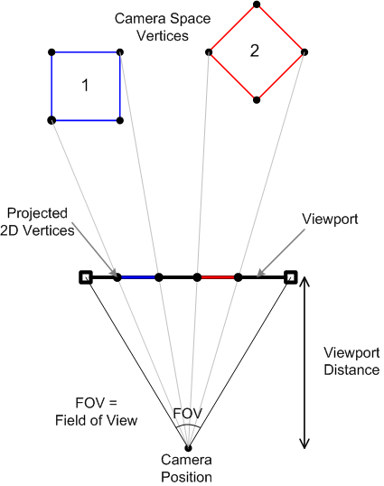

Figure 5‑2 Vertex Projection (Noel, 2017)

There are three factors which a camera possesses which determine what a camera will be able to view, these are named field of view, near clip and far clip distance. Field of view is the angle found when a triangle is formed between the cameras world position and each vertical side of the viewport. Near clip and far clip are two planes which exist, they determine what vertices within the world will be included or omitted from the rendering process, far clip will determine the maximum distance of a vertex which will still be included in the projection process, while near clip determines the minimum distance of a vertex from the camera for it to be included in the projection process.

## Models

3D modelling is a crucial part of modern day games, they play a drastic role in realism within games and help to create a world which is more aesthetically pleasing. The projection of models from 3D space to 2D space has been covered in section 5.5.1, throughout this section the definition, loading and rendering process of 3D models will be covered.

### Predefined Models

Prio Engine possess the ability to create cube and triangle predefined models which can be created through the engine interface. The predefined models can be rendered with solid colours, textures, diffuse lighting, or specular lighting. While the use of predefined models within games is incredibly limited, it serves as a useful debugging tool as each model displays a visual representation of where a model exists in the game world.

### Loading Models

Models within Prio Engine are loaded in through the engine interface, and information about a model is stored in a mesh class to avoid the requirement to load identical model’s multiple times. The mesh class takes a string parameter which refers to the location of the model file, it then parses information about this file through ASSIMP, which loads in vertex, index, normal, UV, and texture data and stores it in member variables belonging to that mesh class.

The texture data which is loaded in through ASSIMP can involve a variety of maps such as diffuse, normal, specular, and alpha maps. It will check the ‘Resources/Textures/’ directory relative to the executable file for all the textures which a model file contains. Through parsing this information, Boolean flags can be set within the constant buffer of the shader file to indicate which maps should be used and which should be ignored. This allows for a flexible approach which will render the mesh using all data available instead of sacrificing techniques which the mesh is missing information for.  
Instances of models are created through the ‘CreateModel’ method belonging to the mesh class. The mesh class stores a list of instances of models, and as a result acts as a form of manager for the model class. Each instance of the model class contains information about the position, rotation, and scale of the model.

### Rendering Models

The vertex and index data are loaded into buffers and stored within the mesh class. By storing information in the mesh class, the same vertex and index buffer can be used to render each model at different positions. The world matrix is calculated for each model through the position, rotation, and scale properties. The world matrix is passed into the shader, and is the only property which changes within the vertex or pixel shader when rendering a group of models.

Prio Engine renders meshes in batches; this is due to the nature of loading information in computers. It is a slow process to retrieve information due to the physical distance between the random-access memory (RAM) and the graphics card, by processing identical data in batches there is a performance gain as the graphics processing unit (GPU) caches model information for it to be reused, and the retrieval of information only occurs once.

The methodology for rendering models on the graphics pipeline is discussed in detail in section 2.4.

### Terrain

Terrain is generated through Prio Engine in a grid based format, each vertex of the grid matches the height provided through the height map, and each area of the terrain is textured depending on its height. The grid is divided into areas based on height, and through analysis of areas within the terrain entities can be positioned within the world.

#### Importing Height Maps

Height maps are generated through a Perlin noise function in Artist Away, however the issue of importing the height map into Prio Engine remains. To solve this, two solutions were presented: passing in height maps through text based files, and passing in height maps through two dimensional dynamic arrays of type double.

The purpose of having two separate standards is allowing for quick loading of a previously generated height map while a two-dimensional array approach allows for slower loading of a more flexible terrain.

In order to satisfy a standard for text based height maps, I have created a ‘.map’ file standard, which contains floating point numbers separated by spaces, and columns separated by new lines. Each number represents a height of a vertex. The dimensions of the height map can be calculated by counting the number of columns and rows. These files are incredibly quick to read in, and enable the programmer to reuse a level multiple times. However, it provides no flexibility, once implemented the terrain cannot be changed by passing another text based ‘.map’ file to the terrain object, however it can still accept a two-dimensional array of type double.

To create a more flexible approach and fully support procedural generation of terrain, a two-dimensional array of type double can also be passed to the terrain object. It works in a similar way to the ‘.map’ standard, however requires the height and width of the map to be passed in as parameters to the function. Each element within the array represents the height of a vertex, and the values of the array are copied into the terrain object as to avoid exceptions by incorrectly deallocating an array which is still in use by another object.

#### Creating Terrain Model

Once a height map is generated, the next step is to plot the vertices for the terrain. Vertices are plotted in a grid formation, the space along the X and Z axis of each vertex is uniform, however the position of the vertex varies along the Y axis. Each vertex is given a UV value to stretch a texture from start to finish across a grid square. Figure 5‑3 demonstrates the use of Perlin noise within procedural generation, and clearly demonstrates the smooth transistions which represent a realistic shape of terrain.

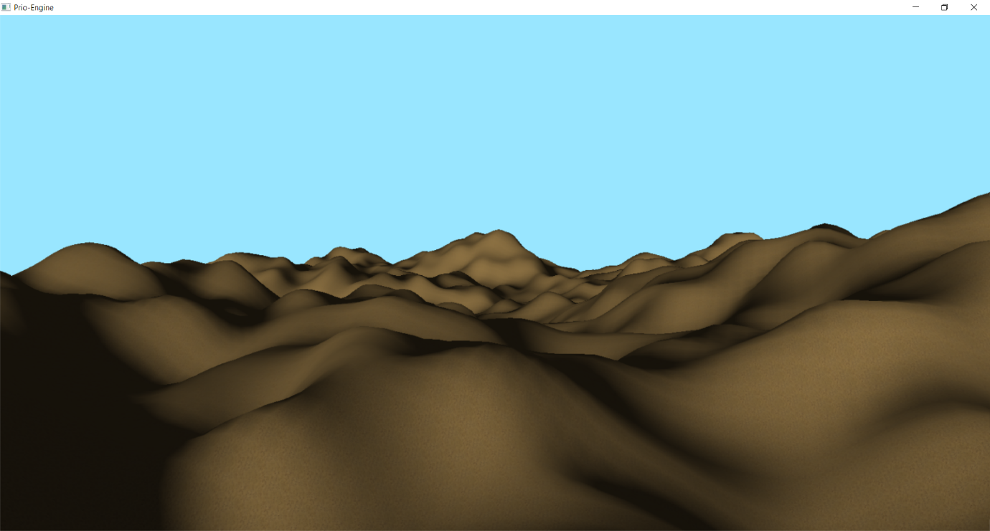

Figure 5‑3 Perlin Noise Based Terrain

The next calculation required for each vertex is the normal calculation. The normal for each vertex is calculated by taking the two connected vertices, all 3 vertices should form a triangle within the grid square. The vertex position is subtracted from the positions of the connected vertices, this should leave two vectors, the cross product of the resulting two vectors is calculated to find the average face vector of the vertex. This process is demonstrated in Listing 5‑1.

// Bottom left

PrioEngine::Math::VEC3 point1 = { vertices[vertex].position.x, vertices[vertex].position.y, vertices[vertex].position.z };

// Bottom right

PrioEngine::Math::VEC3 point2 = { vertices[vertex - 1].position.x, vertices[vertex - 1].position.y, vertices[vertex - 1].position.z };

// Upper right

PrioEngine::Math::VEC3 point3 = { vertices[vertex - mWidth - 1].position.x, vertices[vertex - mWidth - 1].position.y, vertices[vertex - mWidth - 1].position.z };

PrioEngine::Math::VEC3 U = PrioEngine::Math::Subtract(point2, point1);

PrioEngine::Math::VEC3 V = PrioEngine::Math::Subtract(point3, point1);

PrioEngine::Math::VEC3 face1Vec = PrioEngine::Math::CrossProduct(U, V);

float length = PrioEngine::Math::GetLength(face1Vec);

// Normalise the normal.

vertices[vertex].normal = D3DXVECTOR3{ face1Vec.x / length, face1Vec.y / length, face1Vec.z / length };

Listing 5‑1 Face Normal Calculation

Calculating the face normals is required for lighting equations, as without lighting the terrain looks bland and becomes difficult to see curves within the model.

#### Calculating Terrain Type

The next step of procedural generation of terrain is to divide the terrain into areas. To provide a flexible solution which can adapt to a large variety of different shapes of terrain, Prio Engine divides terrain into areas based on their relative height. This is to say, above 60% of the highest point will be rock, above 30% of the highest point will be grass, above 15% of the highest point will be dirt, and anything below will be sand.

Using a percentage based calculation allows for terrains to be scaled, and tiles to be evenly distributed. Each tile is textured with an appropriate texture using tri-planar texture mapping within the pixel shader as discussed in 5.5.8.1.

#### Positioning World Entities

After calculating each tile of terrain, entities are placed upon the terrain to improve the visual appearance of the terrain, and properly reflect the terrain of a real world. World entities are generated on chance given that certain conditions are met. The conditions for generating trees on terrain within Prio Engine are: Must not have another tree located within 30 units, and must be located on a grass or dirt tile. If both conditions are met, then a random number between 0 and 100 is generated, if the random number is less than 2, then a tree is put on a list to be created at that location and at a random rotation, this is the equivalent of giving a 2% chance to create a tree. A similar process occurs for plants; however, a higher percentage chance can be used as tree models have a much higher polygon count and drastically impact performance.

#### Updating Terrain

Updating terrain must be done via a two-dimensional array of type double, there is currently no support through ‘.map’ files to update an existing terrain’s height map, however the terrain object can be destroyed and recreated with another ‘.map’ file at run time.

Updating terrain occurs through the engine object, it accepts a new height map and recreates the terrain based on the new height map. This is quite a lengthy process, so it is recommended to run the process on a separate thread, and join the thread once the new terrain has been created.

After the terrain has been processed, the world entities are required to be recreated, this is another lengthy process and therefore should occur on a separate thread. The ‘RemoveScenery’ and ‘AddScenery’ functions within the engine object make this simple to do, Prio Engine’s graphics object will raise Boolean flags to avoid altering models while they are being raised, this will enable the use of concurrent programming. See 6.4 for more information on concurrent programming.

### Water

A body of water is created within the terrain object, and sits as a flat plane spanning the length and width of the terrain. The water depth defines how high the water will be, and in turn how much of the terrain it will cover. The body of water is created through 4 processes, these are; Rendering a water height map, rendering refraction, rendering reflection, and finally rendering the surface.

The height map for the water is created on a separate render target, as it enables the height map to be passed around as a ‘ShaderResourceView’. The height map is created normal map at four positions, the normals are then totalled to produce the height of the map at that position.

The refractive surface works by only rendering objects which are below the surface of the water, acquiring the terrain colour in the same method as the terrain pixel shader would, and modifying the colour of that terrain depending on the depth of the terrain tile from the water plane.



Figure 5‑4 Reflection Camera

The reflective surface copies the main cameras properties into a reflection camera, however the reflection cameras properties are manipulated in the following ways: the rotation about the X axis of the reflection camera is inverted, the Y position of the reflection camera is moved below the plane of water, however the distance from the water plane does not change, it is simply in the opposite direction, finally the Y axis of the reflection camera view matrix must be inverted, this will prevent reflections being displayed in the incorrect direction on the plane of water. Figure 5‑3 demonstrates how the reflection camera is altered from the properties of the main camera.

The final process of rendering water is to calculate the water surface. In theory, a flat surface which blended reflection and refraction surfaces together would suffice to represent a body of water. However, ripples on the water surface can be generated through manipulating normals which result in light being reflected off the water at different angles, this causes the water surface to appear as though it is moving when in fact, it is a flat surface. A movement variable is updated every frame to alter where the normals are sampled from, this results in moving waves.

Vertex manipulation occurs within the body of water to simulate waves, this provides a more realistic look to the project than if normals and lighting equations where solely relied upon to visualise movement on the water surface. The vertices of the water are plotted in a grid formation, they are altered by accounting for the normal at the current sample position, and multiplied by the wave height, this ensures that the water varies across the surface.

An alternative method of calculating waves are known as Gerstner Waves, this is a method which will simulate the vertex positions of a wave and provides both peaks and troughs (Finch, 2007). While these waves look somewhat more realistic, they have not been implemented within Prio Engine due to time constraints placed upon the project.

### Foliage

Rendering foliage has previously been considered an expensive process, and one which older hardware would struggle to handle due to the strain it would place upon the GPU. However, in modern day hardware this is no longer an issue, as a process named billboarding is commonly used upon three intersecting quads, and foliage drawn as a texture of these quads (Pelzer, 2007).

Prio Engine uses an intersecting quad method to billboard foliage textures, where the quads are positioned in the shape of an asterisks. This result in a thick looking foliage, however when viewed from above the shape is clearly visible. One method which would overcome this issue would be to have one more quad lying flat against the ground, however the appearance may be flawed when viewed from ground level.

The foliage pixel shader makes use of two textures, a diffuse texture, and an alpha map. The diffuse texture contains colour data which will be applied to a model, while the alpha map indicates which areas of the diffuse map are transparent. By discarding pixels which have an alpha value of zero and using an alpha blending state (see section 5.6.2), the intersecting quads appear thick and look as though they are a full 3D model.

Back face culling is a process done within Direct X in which the rear of models is not rendered to improve performance. Rendering of foliage through this method requires back face culling to be disabled, as when the camera views any one quad, the two intersecting quads will have their backs facing the camera, and thus Direct X will not render all the quads to leave us with a full view of the foliage.

While foliage looks thick, it looks unrealistic without movement. To implement movement, each vertex is assigned a value, the value indicates whether the vertex is located at the top or the bottom of a quad. Top vertices are then displaced back and forth to provide the impression of waving grass. This process provides an incredibly cheap method of rendering grass; however, it is not an accurate representation of grass within the real world. To further improve the performance of rendering foliage, each quad is instanced (see paragraph 5.5.8.2).

### Skybox

The skybox within Prio Engine is implemented as a large sphere, in which back face culling (see section 5.6.3) is disabled. The sphere moves with the position of the camera, this gives the impression that the user never gets any closer to the camera, nor any further away. The skybox consists of two colours a horizon colour and an apex colour. The horizon colour is what colour the bottom of the sphere will be, while the apex colour is the colour of the top of the sphere. The two colours are blended together using a gradient, this results in a realistic change in colour representative of a real-world sky.

#### Day, Night, and Evening Cycles

Day, night, and evening times can be represented purely through the skybox. The skybox has an apex and horizon colour which is passed into the pixel shader and rendered every frame, as described in section 5.5.7. The skybox also contains methods to change between day, night and evening pre-set colours. The colour of the skybox is adjusted over time, until it reaches the target colour for both apex and horizon colours.

To create a realistic effect upon the scene, the scene ambient light must be updated to be the same as the horizon colour, this alters the colours slightly of models within the scene, and results in scenes reflecting a real-world time of day.

#### Rendering Clouds

Prio Engine defines a plane which is slightly curved for clouds to move across. Each vertex within the plane is initialised with a texture UV value, to sample cloud textures at that point. Two cloud textures are passed into the pixel shader along with an offset for each texture. The offset is incremented every frame, this results in the texture being sampled at a slightly different position each frame, and thus gives the illusion that the cloud is moving across the plane. This process is incredibly cheap to render and provides realistic looking clouds, however it does contain issues, the plane is visible when reaching the edges of terrain. Usually games would constrict where the user can go within the level to prevent the user seeing the edges of the plane, however that is not an option for Prio Engine currently as it serves as a technical demonstration.

### Texturing

#### Tri-Planar Texture Mapping

The standard method of texture mapping is to sample a texture at dimensional coordinates, this is acceptable when the model matches the resolution of the texture, however upon scaling, textures become distorted and stretched. This is caused by the UV coordinates assuming there is equal distance between each vertex, which isn’t strictly the case with terrain.

One solution to this issue is known as tri-planar texture mapping, it is the process of sampling the texture 3 separate times, one for each axis. All the textures are blended together, this leaves a result in which the dominant direction is primarily used for the blending, and thus removes stretching.

Prio Engine makes use of tri-planar texture mapping upon terrain, as distance between each vertex in terrain is not uniform, tri-planar texture mapping prevents terrain textures from appearing stretched. The result is demonstrated in figure 5‑5.

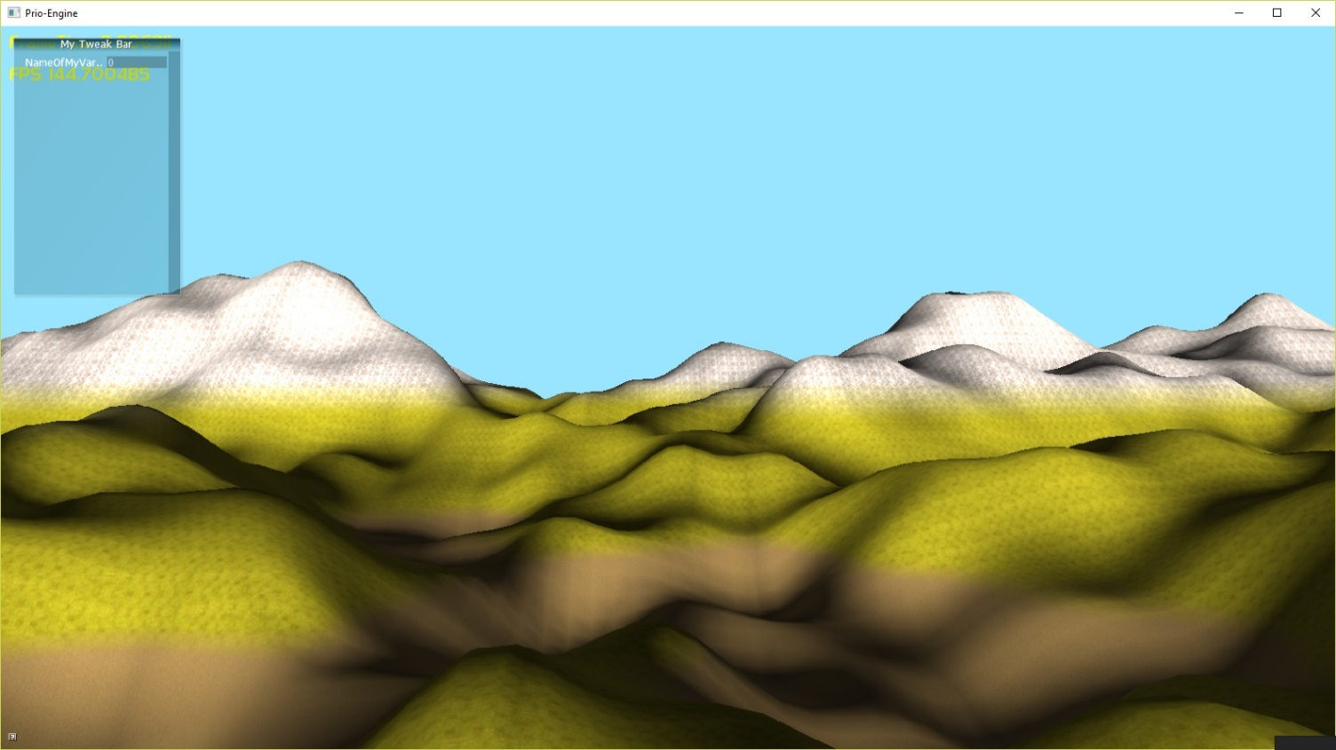

Figure 5‑5 Tri-planar Texture Mapping of Terrain

#### Texture Splatting

Texture splatting is the process of combining two textures together within one area, this creates variety within the texture. This is achieved by sampling a texture at the same coordinate, and using a linear interpolation to smoothly blend between each of the sampled texture colours.

A black and white map is used to define which texture should be sampled at any part. However, without any blending the textures change suddenly, and look unrealistic as they do not overlap smoothly (Crawfis & Max, 1993).

#### Texture Blending

Transitioning between two textures presents a problem, as in the real world we would not expect to see terrain suddenly change. Instead, it is expected that a smooth transition between two types of terrain would occur. This is demonstrated in figure 5‑6, where the unnatural appearance of the change between tiles is evident, and not representative of real world terrain.

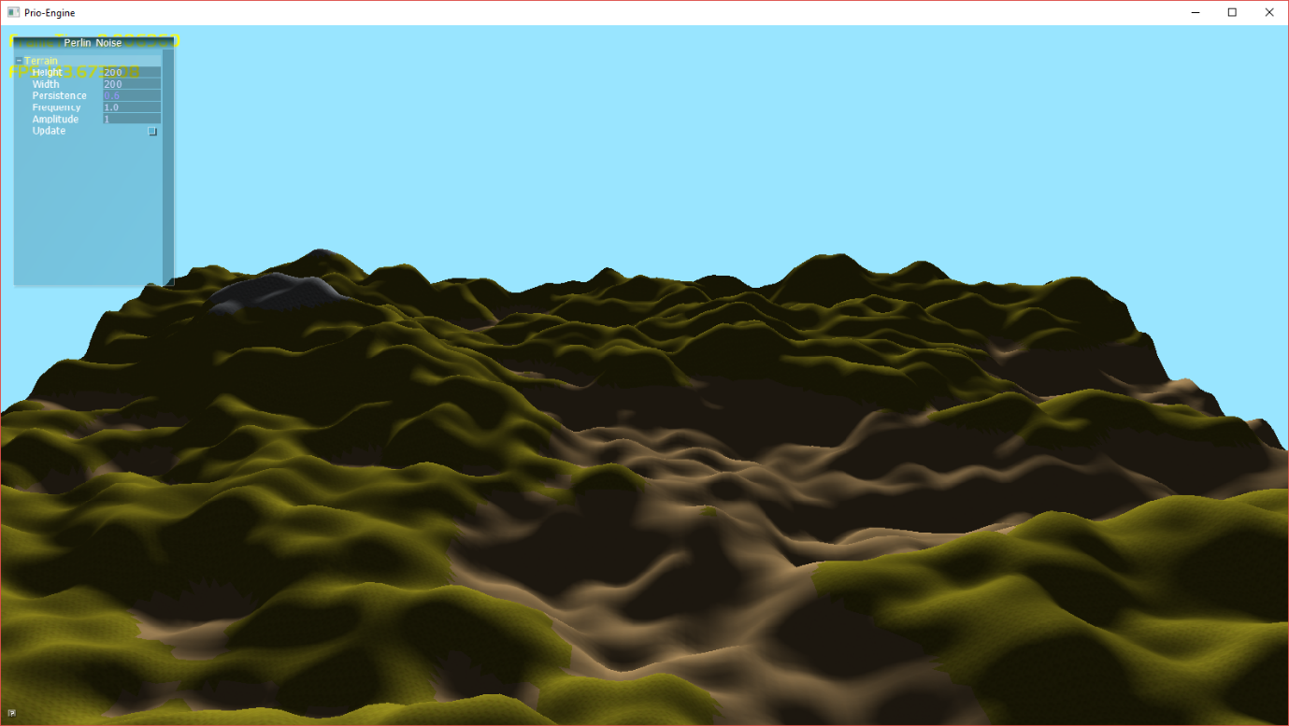

Figure 5‑6 Texturing Without Blending

However, this is not the only problem which is faced when texturing terrain. When a sudden change between textures occurs, artefacts are visible at the seams of the textures, as demonstrated in figure 5‑7.

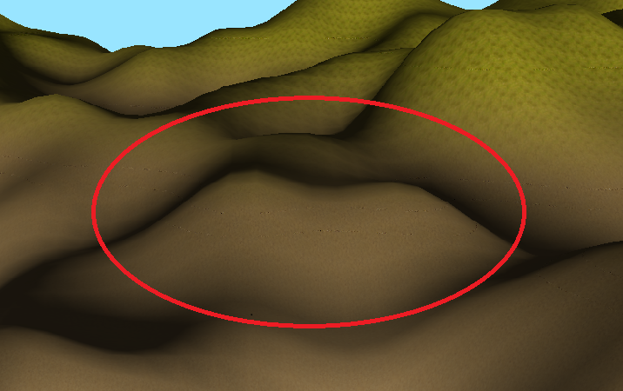

Figure 5‑7 Artefacts on Textures

This has been solved within Prio Engine and Artist Away using linear interpolation, which blends the colour of two textures together. However, it should be noted that this issue can still exist if an incorrect value is used for the blending equation. This error is demonstrated in figure 5‑8.

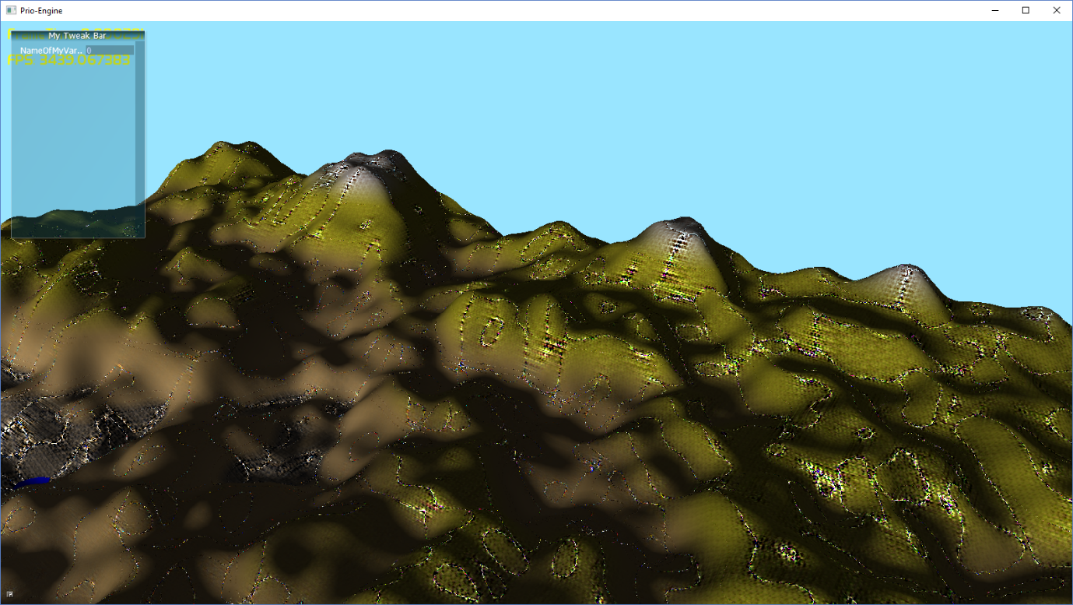

Figure 5‑8 Incorrect Blending Equation Artefacts

### Optimisations

Achieving a constant 60 frames per second is of the utmost importance in any PC game. Optimisations within game engines cover a broad spectrum of issues, however optimisations within Prio Engine are specifically for reducing the load on the GPU.

#### Sphere Based Frustum Culling

Frustum culling is the process of defining planes which surround the cameras viewing angle, and checking if points lie within the planes. If a point sits outside of the planes, then it is not rendered, and potentially saves thousands of polygons being rendered unnecessarily. However, frustum culling does cause issues when large models are visible on the screen and the camera is moving, as the objects appear to pop out of view, particularly if the centre point of a model is at the bottom.

Sphere based frustum culling takes a model and places a theoretical sphere around the model, if the sphere intersects the planes at any point then it is deemed to be inside the planes. This solves the issue of models popping in and out of view, as the model will always be rendered when there is the potential for it to be in view.

#### Instancing

Instancing provides a performance benefit to the graphics pipeline as it removes the necessity to reuse multiple vertex buffers and index buffers, instead the vertex and index buffers are set once on the GPU, and a list of positions and other properties are passed to the GPU. The GPU stores information about each vertex on the geometry shader, and draws it at the position described in the instance data. The performance benefit comes from removing the requirement to pass data to the GPU, which is a lengthy process due to its physical distance from the random-access memory (RAM).

## Rendering Techniques

A wide variety of rendering techniques are available for use with Direct X. These techniques achieve different goals, ranging from appearance to performance.

### Lighting

Lighting improves the realism of a scene, and enables the use of depth and detail within textures. Lighting exists in two forms, directional and point. Directional lights emit light across an entire scene in a constant direction and the strength of the light does not change, while a point light emits from a position in a world in all directions but the strength of the light attenuates depending on the distance from light.

#### Diffuse Lighting

Diffuse lighting is a type of directional light which lights parts of a model which face the light. The facing direction of each vertex in a model is determined through the normal of each vertex.

#### Ambient Lighting

Ambient lighting provides a default lighting to each element on the scene, independent of the lights direction. This is typically applied to every model within the scene and helps to indicate the general colour of the lighting within the scene.

### Blending

#### Alpha Testing and Blending

Alpha testing is a method where the alpha channel of each pixel within a polygon is checked, and if the alpha value is below a threshold then the pixel is discarded. This is a particularly useful method for cutting out textures within pixel shaders using alpha maps. Figure 5‑3 Alpha Testing demonstrates an example of alpha testing used within Prio Engine.



Figure 5‑9 Alpha Testing

Alpha blending allows areas of models to appear transparent, and for other models within the scene to be visible through the transparent areas. While alpha blending is particularly useful on areas where very little depth information is stored, alpha blending struggles to blend areas where objects block vision to other objects. Alpha blending is used scarcely within Prio Engine; however, it is used to blend clouds with the skybox (see Figure 5‑4 Alpha Blending, where black areas of a texture represent an alpha value of zero). This is due to the unlikeliness that there will be any sorting issues either now or in future development with clouds as they are separated from the rest of the scenery.



Figure 5‑10 Alpha Blending

### Back Face Culling

Back face culling is an optimisation technique that occurs when areas of a model should not be visible from the cameras direction, so they are omitted from the rendering process. Back face culling is used for most models in Prio Engine, however it is disabled when the rear view of models is required to be disabled, for example, when rendering the inside of the skybox sphere.

## UI Images

User interface (UI) designs within games are typically created through 2D images being displayed on the screen at a specified pixel coordinate. Prio Engine supports the loading of UI images through the engine class object. These images are particularly useful for providing the user with a heads-up display (HUD) which contains information about the current game or level.

To render UI images the graphics object within Prio Engine stores a base view matrix, which is the view matrix when the main camera is rendered at the origin of the world. This base view matrix is used in place of the camera view matrix when it is passed to the shader, to ensure that the image is displayed at the same position every frame.

## Particle Systems

Particle systems can be created on both the central processing unit (CPU) and the graphics processing unit (GPU). CPU based particle systems tend to be simpler and quicker to implement however data is still required to be passed to the GPU, while GPU based particle systems are slightly more complex and time consuming to implement, and prove to be less flexible than CPU based particle systems. GPU particle systems make use of the geometry shader, which is a stage which sits between the vertex shader and pixel shader in the graphics pipeline. The geometry shader is incredibly efficient at rendering large numbers of the same shape.

### Rain

Rain has been implemented within Prio Engine using a vertex, geometry, and pixel shader. Rain has been implemented as a GPU particle system as rain is something which has very little impact on a game, and where possible should be computationally inexpensive.

The rain particle system requires a vertex and geometry shader to update the rain particles, and a vertex, geometry, and pixel shader to draw the rain particles to the screen. The update geometry shader determines whether a particle is an emitter or a rain droplet, if it is an emitter then a new rain droplet is defined and positioned at a random location within a set radius, and this droplet is appended to the existing particles. The draw shaders are responsible for moving the position of the existing rain droplets, and setting the colour of the rain droplets.  
Each rain particle is rendered as a point line, this was selected for rain as droplets fall so fast that the user would not be able to recognize the actual shape of the droplet. A key benefit of rendering droplets as a line list is that it reduces the number of vertices which are required to be rendered, this takes more strain off the GPU and ensures a cheap method of rendering.

### Snow

Snow is rendered in an identical manner to rain described in section 5.8.1, the only difference lies in the colour which is used within the pixel shader and the speed at which the snow falls. The length of each line calculated within the geometry shader is determined by the current acceleration of the particle. By slowing the particle down, the line is reduced to a small dot, which resembles a very fine snowflake.

## Summary

Prio Engine makes use of a wide variety of techniques to create a flexible Direct X 11 based game engine which can serve for the use of multiple projects, however focusses on the support of terrain generation. The engine is based solely upon graphics, and relies on any physics calculations to be implemented by other developers. Due to Prio Engine’s design to be used as a static library, a multitude of features are required to be implemented, however it is not necessary that all of them be used in each project.

# Artist Away

Artist Away is responsible for controlling and generating height maps which are used within Prio Engine. Height maps are required to be manipulated during run time through a variety of parameters used within noise algorithms. Throughout this section, the method of generating height maps used for terrain will be explored, as well as the methodology behind enabling the update process to occur during run time.

## Perlin Noise Generation

Perlin noise is a type of noise which generates a smooth style of noise between values 0 and 1. It was introduced by Ken Perlin, however he later released his improved Perlin noise algorithm (Perlin, 2002). Artist Away makes use of improved Perlin noise to generate height maps with values between 0 and 1. These values can be amplified by a control known as ‘gain’ to uniformly alter the values.

Perlin Noise can be calculated on either the central processing unit (CPU) or graphics processing unit (GPU) (Green, 2005). Artist Away pursues a CPU implementation of Perlin Noise, as it is simple to write noise generated on the CPU to a file, whereas it becomes slightly more complex when the noise is generated in a shader. Perlin noise can be generated in two-dimensional or three-dimensional space. Artist Away generates Perlin noise in two-dimensional space, as three-dimensional space poses very few benefits in generation of terrain.

Perlin noise accepts an x, y and z parameters which represent the coordinates of a point. These parameters are normalized to find the position of this coordinate within a square. Four pseudorandom gradient vectors are generated from the four points of the square. Four more distance vectors are generated which calculate four surrounding points on a grid about each point on a square. The dot product between the pseudorandom gradient vector and the distance vector generate influence values, which will determine how strong a noise value will be. Four influence values are generated as there are four separate points on a square in 2D noise, however in 3D noise eight values would be required. A linear interpolation is performed upon each of the influence values with one another to perform a smooth transition throughout each Perlin value generated, however due to the way in which linear interpolation this curve looks unnatural. To make the curve more natural, an ease curve is applied to further smooth the curve between each of the values.

Perlin noise accepts a series of parameters to manipulate noise, these include; amplitude, persistence, frequency, and octaves. Amplitude controls how high a noise value can possibly be when it is calculated. Persistence calculates how quickly amplitude will deteriorate. Frequency controls how drastic the changes in the noise values will be. Octaves are the number of times which the Perlin value will be calculated, and then added to a total number. Each of these effects are controllable through Artist Away, as they enable a method of customizing height maps which can be used for both terrain generation and foliage generation.

## Creating and Exporting Height Maps

Height Maps are created through Perlin noise, described in section 6.1. The map itself is stored as a two-dimensional dynamic array of type double, and can be acquired through the ‘GetMap’ function belonging to the height map class.

As mentioned previously in section 5.5.4.1, height maps must adhere to two standards, and Artist Away is responsible for adhering to each of these standards. The first standard is a two-dimensional dynamic array of type double. Artist Away generates this and stores all information regarding the height map in a member variable which is a dynamic array. The height map class allows access to the dynamic array, however if objects deallocate memory from this array then it will cause a runtime error during the shutdown function of the height map. For this reason, it is recommended that height maps are generated and stored in text files, matching the ‘.map’ file standard. The only time when a dynamic array based heightmap is recommended is when the height map is required to be generated in real time, this is the case with procedural generation, and as a result is the chosen method for Artist Away.  
Artist Away also exports height maps which are created as text file with a ‘.map’ extension. A space separates each column; a new line separates each row. These text files can be loaded in to a dynamic array by analysing the text file, this process occurs within Prio Engine.

## User Interface

### Controlling the Game

The camera movement is controlled through W, A, S, and D keys, while the rotation of the camera is controlled through up, down, left and right arrows. AntTweakBar is used to control elements within the scene.

### AntTweakBar Usage

The user interface within Artist Away is primarily implemented through AntTweakBar. The tweak bar allows for manipulation of height maps, control over weather effects and manipulation of water properties. The tweak bar is implemented through callback functions which are used as getters and setters to alter the values within the engine. Callbacks are used in place of basic read only and set variables as callbacks prevent the requirement to update variables within the engine every frame, and allow for concurrent programming.

## Concurrent Programming

Concurrent programming is the process of running tasks in the same process on different threads, however it is renowned for being troublesome within games. Once troubles regarding concurrent programming have been overcome, it can provide a great performance boost the project. This chapter covers the use of concurrent programming within games and procedural generation.

### Multithreading Noise Generation

It was found that generating Perlin noise on the CPU is an incredibly intensive process, and thus takes a long time to process. To keep the game operational while height maps are being updated, Artist Away runs all generation of height map and updating of terrain on a separate thread. This enables the user to continue using Artist Away while the new terrain is being generated.

Multithreading is only possible through callbacks within Artist Away, as AntTweakBar does not run callbacks on a separate thread, they must be manually created and joined through the program which runs AntTweakBar. A Boolean flag is raised in Artist Away when the thread is ready to be re-joined to the main thread, this flag is checked in every frame of the main thread, once the thread is re-joined to the main thread, it no longer runs.

### Preventing Multithreading Issues

Multithreaded programs are prone to errors when two separate threads attempt to use the graphics device or information passed the graphics device at the same time. Multithreading within Artist Away operates upon modifying elements and member variables belonging to the engine object, all the while the engine object is still running on the main thread and uses many member variables throughout every frame. One area which proved particularly problematic was modifying the meshes and models used when updating the terrain object. Issues arise as the main thread attempts to render a list of models contained by each mesh, while the separate thread attempts to remove the models belonging to that mesh, to generate new models at the correct position. This is solved by raising and lowering Boolean flags when the render method for meshes starts and ends, the second thread will wait for the flag to be lowered before continuing and modifying the list of models. This does mean that the second thread will not run as quickly as it possibly could, however it ensures that the program will not crash.

## Updating Terrain During Run Time

The update process is triggered through a button click event in AntTweakBar, which in turn calls a callback function to begin the update. The update process is run on a separate thread as to avoid causing the program to hang.

### Generating New Height Map

Height maps are stored as two dimensional dynamic arrays of type double. Height maps can be updated through the ‘Update’ function found in the class declaration. It is required that the programmer sets the new height and new width of the height map before calling the update function, unless they wish for the height map to remain the same dimensions. Upon calling the update function, all memory for the existing dynamic array is deallocated, to apply the resize the array is allocated memory of the newly requested width and height. The initialisation process runs upon the new dynamic array to populate it with Perlin noise values.

### Updating Entities

There are four elements which are built around height maps which will need to be regenerated; terrain, water, foliage, and terrain entities (trees and bushes). Before updating occurs, the engine is instructed that updating of these entities is about to occur, this avoids render functions attempting to render entities which are being modified. The update function of terrain is called, the update function is responsible for shutting down allocated memory, and following that it will reinitialise the terrain by beginning the procedural generation process with the new height map.

Once the terrain has been regenerated, Prio Engine update the water object. The water is destroyed, and recreated and the same width and height as the terrain. This ensures that the water sits as a flat plane throughout the terrain, and does not only cover certain areas within the terrain.

Following the water, a new height map is generated for foliage. Foliage is generated by analysing a map of equal height and width to the terrain height map, but the foliage height map should have a much higher frequency.

Finally, the terrain entities are updated. The simplest method of reinitialising the terrain entities is to remove all model instances belonging to the mesh object, and recreate them from the positions generated by the terrain object which was regenerated in the first stage of recreation.

# Test Strategy

## Introduction

Software testing is essential to ensuring the stability of a product and allowing for continued development without unexpected behaviour occurring because of previously written incorrect code. It is important to note that a failed test is a correct test, as it is uncovering bugs within the code. Testing also analyses the severity of the bugs within code to dictate a course of action, throughout this section bugs within the program will be uncovered, however some may not be fixed depending on severity, this is an informed decision made by the developer to progress development of Prio Engine and Artist Away as much as possible.

All testing for Prio Engine has taken place on a computer with an NVidia GTX 970 graphics processing unit (GPU), an intel i5 6600k clocked at 4.2GHz, and 16 gigabytes of random access memory (RAM) available. However, some more testing has been conducted on a machine with similar specifications, but an NVidia GTX 670 graphics card. This is essential to testing as it pushes the boundaries of what Prio Engine and Artist Away can perform on.

## Creating a Test Harness

Prio Engine is created as a static library, and therefore requires a method of testing which allows Prio Engine to be run as an application. To achieve this, a win32 project is set up for Prio Engine, which allows a window to be started and Prio Engine to be run in the created window. This is convenient for testing purposes as Prio Engine can be developed within the test harness, once a feature is implemented then it is exported as a static library, finally the updated static library is implemented within Artist Away.

## Time Dedicated to Testing

The methodology behind testing and when to start testing was briefly outlined in section 3.2.3 however, when testing should stop and development should be resumed has never been clarified. A common approach is to analyse the reliability of the software and weigh up the cost of testing with risk of bugs in the software. While this method works to an extent, it is not incredibly flexible for a project with a fixed deadline, and therefore not an awful lot of use to the project.

The failure size proportional model considers the severity of items if they were to fail against the cost of testing (Zachariah, 2015). This provides the flexibility to continue development where necessary, and ensure that development efforts are not being focused in the incorrect areas of the project.

It should be noted that although a large portion of testing has occurred towards the end of development, testing has been an ongoing process throughout the development process. An incredibly relaxed approach to test driven development has been the driving force behind ensuring the program is free of bugs, as often new features are not implemented until the current feature being developed is considered to work.

## Testing Prio Engine and Artist Away

Testing is crucial to any technical demonstration, as there is little margin for error. However due to the scope of the project and accounting for both testing and development time, it is vital to accept that all bugs may not be eradicated, and instead to focus on becoming aware of the bugs and organising fixes by severity of each bug. Manual testing has been used over the use of automation due to the requirement of time to develop a test automation suite. This section covers how test cases are established and how the project is tested.

### Identifying Test Cases

An incredibly effective method of identifying software requirements and test cases is the ’10 Minute Test Plan’. It involves grouping up developers, and having each of them write down everything they expect a piece of software to achieve, and what is required of that software. At the end of the 10 minutes, each of the developers collaborates, crosses off any duplicate requirements and creates test cases from the remaining requirements. It has been found that this method is incredibly effective at defining attributes which describe the software, components which will be required to be implemented within the software and the capabilities which the software can achieve (Whittaker, 2011).

The idea of a ten-minute test plan is not strictly applicable to Artist Away or Prio Engine, as all development is the product of one person, however a similar concept can be applied and the single developer (in this case, myself) can quickly outline all core concepts and requirements of the software. The resulting requirements can be found in Figure 7‑1.

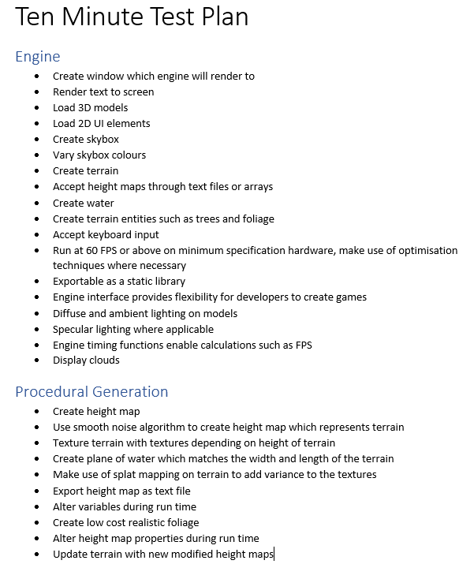

Figure 7‑1 Ten Minute Test Plan

The ten-minute test plan leaves a basic list of all requirements which the developer believes the engine should compute, from these requirements test cases must be derived, this process is outlined in sections 7.4.2 and 7.4.3.

### Engine Testing

Feature testing for Prio Engine has been split into two areas; performance and functionality. This ensures that Prio Engine meets the requirements set out in the test plan, and operates to meet the minimum requirements. Performance test cases are set out in table 1 where requirements and minimum standards for testing have been laid out into a script.

Table 2 demonstrates the functional requirements of the engine. By testing the functional requirement, it is ensured that the developer is made aware of whether the project meets the technical requirements set out by the scope of the project.

Table 3 tests for the ability to render 3D models within the engine. This is essential as part of the scope of the project is to develop an engine which is flexible enough to be reused in future projects, by testing the ability to control and render 3D models, it is ensured that Prio Engine is flexible and stable enough to be reused for future demonstrations.

### Procedural Generation Testing

Procedural generation has been the primary focus of the project as everything built within the engine has been designed to support procedural generation, this results in a requirement for thorough testing to ensure that the target of the project is met. Table 4 demonstrates the test cases required to ensure that procedural generation takes place correctly, and the technical demonstration is in fact ready for release.

## Summary

There are areas within Prio Engine and Artist Away which fail testing, however this proves that testing of both projects has been effective and enables bugs to be tracked. It’s also important to note every test case has failed at one point in time throughout development, however a relaxed approach to test driven development ensures that the program has been developed to meet the test case criteria.   
The areas which still fail have been deemed non-crucial to continue development of Artist Away and Prio Engine, and therefore have been omitted from the fixing process as remaining development time may possibly be spent in more useful ways.

# Evaluation, Conclusions, and Future Work

## Project Objectives

The purpose of Prio Engine was to create a game engine which focused on supporting procedural generation of terrain. Prio Engine meets the criteria of a game engine, it is responsible for loading resources, managing loaded resources, rendering entities, and controlling entities. It also successfully supports extra features such as in game text, UI images, weather effects, water creation, foliage creation and foliage effects. Prio Engine has extended beyond its initial scope to create a flexible, reasonably efficient, and modifiable game engine.

Artist Away on the other hand set out to achieve a project which allowed procedural generation to occur within Prio Engine using generated height maps. The project has been a success, as terrain is successfully created through height maps supplied through Artist Away, it has also been extended to allow terrain to be generated countless times during run time, and different shapes of terrain to be generated via modifiable height maps.

## Applicability of Findings to the Commercial World

As a product of Artist Away and Prio Engine, a procedurally generated level has been successfully created, without any input from an artist. This finding can be taken and applied to real world scenarios, as it proves that realistic levels can be generated without any involvement from a level designer.

However, it is important to note that the development of procedural generation of terrain is incredibly time consuming, without using a previously built procedural generator for terrains, commercially and financially it makes more sense to hire an artist who designs levels. This is in part due to the predictability of predesigned levels, if every level is the same, terrain need not be analysed by a computer to decide where entities should be placed. In fact, it is much faster to place entities through a rule of thumb which an artist can create, and removes any form of randomness from the process. Within procedural generation of terrain, an issue arose when attempting to decide when to create a tree. A combination of a random number generator and radius between all other trees was used to solve this issue, to prevent a uniform pattern being clearly visible. This appears realistic within terrain, however it would face issues if a player in the world were to make use of entities within the world, as there is no guarantee that an entity would ever be created, nor is there any knowledge of what position an entity would be created within the terrain.

Prio Engine was successful at rendering elements, loading resources, supporting procedural generation, updating elements in real time and all around performing the requirements of a direct X 11 game engine. Prio Engine could theoretically be used in any number of future projects, as the game engine is reasonably efficient, runs with no memory leaks at runtime (although some exist within the shutdown process), and supports a wide variety of features expected to be found within an engine.

## Evaluation

Upon creation of Prio Engine, it was not clear whether the engine would be separate from Artist Away as a project, or development would occur within one project. It was later decided that Prio Engine would operate separately from Artist Away, as it would enable for future use of Prio Engine with other projects. This should have been decided at the beginning of the project, as it resulted in Prio Engine containing elements which are specific to Artist Away. This is acceptable for this project; however, it should be recognized that Prio Engine could be reduced in file size and thus lower the file size of future projects. It may improve the performance of the engine by removing unnecessary classes, and unnecessary initialisation processes.

However, this wasn’t the only issue that should have been recognised before development commenced. An equally as important issue was the issue of concurrent programming within Artist Away. It was not acknowledged that the generation process would have a drastic impact on performance, and thus be required to run on a separate thread. Multithreading caused numerous issues throughout Prio Engine, as frequently the second thread would modify member variables which were used by Prio Engine, which would then result in crashes, particularly if two threads attempted to use the same element at the same time.

## Conclusions

Artist Away demonstrates that procedural generation of terrain can be done effectively, however, it is only cost effective when the procedural generation program has been previously implemented, or can be reused in future. If procedural generation is only used on one occasion, it is simply more cost effective to hire a level designer. However, it is important to note that procedural generation occurs without mistakes, human errors are something which cannot be accounted for, therefore if reliability is key in a project then procedural generation should be chosen.

Prio Engine demonstrates that a game engine can be written with the specific purpose of supporting procedural generation and make use of Direct X 11. Although other game engines provide support for procedural generation, none focus on simplifying generation and loading of terrain like Prio Engine.

## Future Work

Another improvement which could have been recognised within the development process was the implementation of water. The water implemented was incredibly complex, and thus took a considerable amount of development time. Water was not initially part of the plan to procedurally generate terrain, this is something which almost certainly should have been recognised earlier in the planning stages. Although water was complex to implement and was a drain upon available development time, it should be noted that water has drastically improved the visual aesthetics of the terrain, and certainly improved upon its realism.

Performance of Prio Engine on low end hardware was certainly something which should have been investigated. Instancing was a technique used upon quads to cache vertex data on the GPU, however it could also theoretically have been used on meshes within Prio Engine. This would have drastically improved performance of the engine, however it would also have altered the method in which frustum culling was used. Test cases would need to be performed, would it be faster to perform frustum culling and reconstruct the instanced data every frame, or faster to render all instanced models every frame without performing frustum calculations. By improving the performance of Prio Engine, much larger levels could have been generated and displayed, this would have enabled the demonstration of Artist Away and Prio Engine to be much more effective, as it allows a visualisation of just how far procedural generation can be taken. An alternative to instancing which may be used is the use of tree meshes with a lower polygon count. Currently, the tree models are incredibly detailed and put an enormous amount of strain upon the GPU, with more simplistic models the engine would find it much less strenuous to render scenes on a much larger scale.

To further improve the performance of Prio Engine, it should be updated to compile at 64 bit. Currently, Prio Engine only supports 32 bit due to the method of compilation used with ASSIMP. By updating Prio Engine to use 64 bit, it expands future flexibility as the memory available to the program is drastically improved. This is typically useful for complex physics in games. It would be useful for Prio Engine to support 64 bit for future usage, as it is likely that physics will be implemented in a future version of Prio Engine. The benefit of 64 bit applications, particularly for physics, are that they allow more accurate representation of floating point numbers, and as a result can be used to calculate and represent more accurate calculation of physics equations.

To further the realism of the scene, it would have been ideal to include a campfire at the highest position on the terrain which is reasonably flat, this would further demonstrate the analysis of terrain that can occur to select a position for various entities. Fire can run as a GPU based particle system, this would have resulted in little to no impact upon performance of Prio Engine. However, there was simply not enough remaining development time in the project budget to implement this feature.

Furthermore, snow could also have been drastically improved throughout the engine, as in its current implementation snow does not stick to the terrain once it has fallen, this would have added to the realism of representing a real-world terrain with weather effects. The implementation of this feature would have determined how performance would have been impacted. However, one method which would have had no impact upon performance would have been to alter the texture, after snow has fallen for a set amount of time, and only use the snow texture when the normal of a vertex faces in an upwards direction.

One final addition to the project would have been to implement the Doppler effect as rain drops fell into the water. This would have improved the realism of the rain particle system, and improved the aesthetic and realism of the body of water.

Quad trees are used to divide areas up into quads, each quad can then be treated as a separate 3D model to help separate up larger 3D models. The use of quad trees serves great purpose within terrain, as it allows for the terrain to be divided into separate areas. Dividing terrain into areas is useful for several reasons, primarily it enables frustum culling of terrain which is divided into areas, this prevents unnecessarily rendering areas which are displayed off screen. Furthermore, using quad trees allows for analysis of areas of the terrain, if an area is consists mostly of grass tiles then the Artist Away could indicate that there should be an increased chance to create foliage at that position. This helps to generate a more accurate terrain and reduces the number of mistakes or misplaced entities created in procedural generation.

## Concluding Reflections

Prio Engine has successfully created a Direct X 11 engine which supports procedural generation of terrain, and loading of height maps to generate terrain. However, it currently lacks optimisation techniques which are desired, as it would enable terrains of a much larger scale to be generated and rendered.

Procedural generation of terrain is an effective method of bypassing the requirement for a level designer, and incredibly reliable as terrain can be generated without mistakes. However, it is important to note that to create a generator is incredibly time consuming, and is only worthwhile when there is reusability potential, or when reliability is paramount. Furthermore, procedural generation can be improved using quad trees, and reflection of real world terrain could be further enhanced through analysis of quad trees, rather than height based analysis of tiles.

# Bibliography

Ali, Z. (2016) *'A Framework for Game Engine Selection for Gamification and Serious Games',* San Francisco, IEEE, pp. 1199-1207.

Bach, J. (1998) 'A Framework for Good Enough Testing', *Computer,* 31(10), pp. 124-126.

CEGUI, (2016) *Crazy Eddie's GUI,*   
http://cegui.org.uk/  
(accessed 19 April 2017).

Crawfis, R. A. & Max, N. (1993) *'Texture Splats for 3D Scalar and Vector Field Visualization',* San Jose, IEEE Computer Society.

Finch, M. (2007) *Effective Water Simulation from Physical Models,*   
http://http.developer.nvidia.com/GPUGems/gpugems_ch01.html  
(accessed 9 April 2017).

Green, S. (2005) *Implementing Improved Perlin Noise,*   
http://http.developer.nvidia.com/GPUGems2/gpugems2_chapter26.html  
(accessed 11 April 2017).

Gregory, J. (2012) *'Game Engine Architecture',* 2nd edition, Natick: A K Peters, Ltd..

Hello Games, (2016) *'No Man's Sky',* Guildford: Sony Interactive Entertainment.

Horn, B. et al. (2014) *'A Comparative Evaluation of Procedural Level Generators in the Mario AI Framework',* Lauderdale, Society for the Advancement of the Science of Digital Games, pp. 1-8.

id Software, (1993) *'Doom',* Mesquite: GT Interactive.

Jacobson, I., Spence, I. & Seidewitz, E. (2016) 'Industrial-Scale Agile--From Craft to Engineering', *Communications of the ACM,* 59(12), pp. 63-72.

Jiang, B. & Chan, W. K. (2016) *'Testing and Debugging in Continuous Integration with Budget Quotas on Test Executions',* Vienna, IEEE.

Julian, T., Preuss, M., Beume, N. & Wessing, S. (2013) 'Controllable Procedural Map Generation via Multiobjective Evolution', *Genetic Programming and Evolvable Machines,* 14(2), pp. 245-277.

Luna, F. D. (2012) 'Introduction to 3D Game Programming WIth DirectX 11', in *Introduction to 3D Game Programming WIth DirectX 11,* Dulles: Mecury Learning and Information, pp. 655-660.

Mark, B., Berechet, T., Mahlmann, T. & Togelius, J. (2015) *'Procedural Generation of 3D Caves for Games on the GPU',* Pacific Grove, Lund University.

Microsoft, (2015) *DLLs in Visual C++,*   
https://msdn.microsoft.com/en-us/library/1ez7dh12.aspx  
(accessed 25 03 2017).

Microsoft, (2015) *Walkthrough: Creating and Using a Static Library (C++),*   
https://msdn.microsoft.com/en-us/library/ms235627.aspx  
(accessed 25 03 2017).

Microsoft, (2017) *Graphics Pipeline,*   
https://msdn.microsoft.com/en-us/library/windows/desktop/ff476882(v=vs.85).aspx  
(accessed 19 April 2017).

Mikuličić, N. & Mihajlović, Ž. (2016) *'Procedural Generation of Mediterranean Environments',* Opatija, Information and Communication Technology, Electronics and Microelectronics (MIPRO).

MyGUI, (2007) *MyGUI,*   
http://mygui.info/  
(accessed 19 April 2017).

Neumann, P. G. (2016) 'Risks of Automation: A Cautionary Total-System Perspective of Our Cyberfuture', *Communications of the ACM,* 59(10), pp. 26-30.

Noel, L. S. (2017) *'World, View and Projection Matrices',* Preston: University of Central Lancashire.

Nystrom, R. (2014) 'Game Programming Patterns', in *Game Programming Patterns,* USA: Genever Benning, pp. 123-139.

Onal, E. et al. (2014) *'Decision-making in abstract trust games: A user interface perspective',* New Orleans, Cognitive Methods in Situation Awareness and Decision Support (CogSIMA).

Pelzer, K. (2007) *Rendering Countless Blades of Waving Grass,*   
http://http.developer.nvidia.com/GPUGems/gpugems_ch07.html  
(accessed 9 April 2017).

Pereira, D., Zárate, L. & Song, M. (2013) *'Applying Formal Concept Analysis to Assist Class Hierarchy Construction in Biomedical Systems',* Hangzhou, IEEE.

Perlin, K. (2002) 'Improving Noise', *ACM Transactions on Graphics,* 21(3), pp. 2-3.

Whittaker, J. (2011) *The 10 Minute Test Plan,*   
https://testing.googleblog.com/2011/09/10-minute-test-plan.html  
(accessed 3 April 2017).

Wilson, J. M. (2003) 'Gantt charts: A Centenary Appreciation', *European Journal of Operational Research,* 149(2), pp. 430-437.

Zachariah, B. (2015) 'Optimal Stopping Time in Software Testing Based on Failure Size Approach', *Annals of Operations Research,* 235(1), pp. 771-784.

Appendix 1 – Project Gantt Chart

|  |  |  |  |  |  |
| --- | --- | --- | --- | --- | --- |
| Task Mode | Task Name | Duration | Start | Finish | Predecessors |
| Auto Scheduled | Setup git project | 0 days | Thu 01/09/16 | Thu 01/09/16 |  |
| **Manually Scheduled** | **Initial program setup** | **12 days** | **Thu 01/09/16** | **Thu 22/09/16** | **1** |
| Auto Scheduled | Create Window | 1 day | Thu 01/09/16 | Sun 04/09/16 |  |
| Auto Scheduled | Set up swap and chain | 2 days | Sun 04/09/16 | Wed 07/09/16 | 3 |
| Auto Scheduled | Set up remaining areas of Direct X | 4 days | Wed 14/09/16 | Wed 21/09/16 | 4 |
| Auto Scheduled | Create a logger | 1 day | Wed 21/09/16 | Wed 21/09/16 |  |
| **Manually Scheduled** | **Create engine** | **10 days** | **Thu 22/09/16** | **Sun 09/10/16** | **2** |
| **Manually Scheduled** | **Create primitives** | **2 days** | **Thu 22/09/16** | **Mon 26/09/16** |  |
| Auto Scheduled | Create triangle primitive | 1 day? | Thu 22/09/16 | Sun 25/09/16 |  |
| Auto Scheduled | Create cube primitive | 1 day? | Thu 22/09/16 | Sun 25/09/16 |  |
| Auto Scheduled | Implement polymorphism for primitives | 1 day | Sun 25/09/16 | Mon 26/09/16 | 9,10 |
| **Manually Scheduled** | **Create pixel and vertex shaders** | **2 days** | **Mon 26/09/16** | **Thu 29/09/16** | **8** |
| Auto Scheduled | Create solid colour pixel shader | 1 day? | Mon 26/09/16 | Wed 28/09/16 |  |
| Auto Scheduled | Create texture pixel shader | 1 day? | Mon 26/09/16 | Wed 28/09/16 |  |
| Auto Scheduled | Create texture and diffuse lighting pixel shader | 1 day? | Wed 28/09/16 | Wed 28/09/16 |  |
| Auto Scheduled | Implement loading of models | 2 days | Thu 29/09/16 | Mon 03/10/16 |  |
| Auto Scheduled | Implement camera and model control | 3 days | Mon 03/10/16 | Sun 09/10/16 | 16 |
| **Manually Scheduled** | **Procedurally generate level** | **26 days** | **Sun 09/10/16** | **Wed 23/11/16** | **7** |
| **Auto Scheduled** | **Generate height map** | **8 days** | **Sun 09/10/16** | **Mon 24/10/16** |  |
| Auto Scheduled | Create Perlin noise maps | 5 days | Sun 09/10/16 | Wed 19/10/16 |  |
| Auto Scheduled | Compile Perlin noise maps together | 3 days | Wed 19/10/16 | Mon 24/10/16 | 20 |
| **Manually Scheduled** | **Apply terrain properties to areas of height map** | **5 days** | **Mon 24/10/16** | **Tue 01/11/16** |  |
| Auto Scheduled | Create basic textures to be positioned height map | 4 days | Mon 24/10/16 | Mon 31/10/16 |  |
| **Manually Scheduled** | **Testing** | **16 days** | **Sun 27/11/16** | **Sun 25/12/16** | **2,7,18** |
| Auto Scheduled | Write test script | 1 day? | Sun 27/11/16 | Mon 28/11/16 |  |
| Auto Scheduled | Write unit tests | 10 days | Mon 28/11/16 | Wed 14/12/16 | 25 |
| Auto Scheduled | Run unit tests | 1 day? | Wed 14/12/16 | Sun 18/12/16 | 26 |
| Auto Scheduled | Conduct manual testing | 4 days | Sun 18/12/16 | Sun 25/12/16 |  |
| **Manually Scheduled** | **Procedurally generate terrain elements** | **21 days** | **Wed 28/12/16** | **Wed 01/02/17** | **22** |
| Auto Scheduled | Generate grass | 5 days | Wed 28/12/16 | Wed 04/01/17 |  |
| Auto Scheduled | Generate rocks | 5 days | Thu 05/01/17 | Sun 15/01/17 |  |
| Auto Scheduled | Generate trees | 5 days | Sun 15/01/17 | Mon 23/01/17 |  |
| Auto Scheduled | Generate sand | 5 days | Mon 23/01/17 | Tue 31/01/17 |  |

Table 1 - Gantt Chart

Appendix 2 – Engine Class Diagram



Figure 9‑1 Engine Class Diagram

Appendix 3 – Test Cases

Table 2 – Memory Test Cases

|  |  |  |  |  |
| --- | --- | --- | --- | --- |
| **Test Case** | **Pass Criteria** | **Result** | **Severity** | **Action** |
| Run Prio Engine executable, monitor RAM usage in Windows Task Manager. | RAM usage should be consistent, should not gradually rise as that indicates memory leaks exist within the program and it will eventually crash. | Passed | Urgent | None required. |
| Run Prio Engine in Visual Studio Debug Mode, use the CRT library to check for memory leaks. | No memory leaks should be found in the program, Prio Engine should be responsible for cleaning up allocated memory. | Failed | Low | Go through all code and ensure all Direct X types are correctly released if they have been initialised, and a corresponding delete exists for any object which is allocated memory. |
| Run Prio Engine release executable, monitor the FPS through in game text. | The FPS counter should never drop below 60 frames per second on GTX 960 (minimum spec graphics card). | Passed | Urgent | None required. |

Table 3 - Engine Test Cases

|  |  |  |  |  |
| --- | --- | --- | --- | --- |
| **Test Case** | **Pass Criteria** | **Result** | **Severity** | **Action** |
| Load a mesh through the mesh class which makes use of ASSIMP. | No errors should be thrown, vertex, index, and texture data should be loaded into mesh object. | Passed. | Urgent | None required. |
| Create model from an instance of a mesh, render the model. | Model should be displayed on screen at the correct position in the world. | Failed. | Low | Models are loaded in at a 90-degree rotation, can simply rotate the opposite way for the time being. |
| Create terrain entity from supplied height map. | Terrain entity should be rendered in world space around coordinates (0,0,0). | Passed. | High | None required. |
| Create body of water. | Body of water should span the width and length of the terrain. | Passed. | Medium | None required. |
| Create body of water. | All elements within the scene which are below the water surface should be refracted. These elements include | Passed. | Low | None required. |
| Create body of water | All elements above the water which are visible should be reflected. | Failed. | Low | Terrain is currently refracted, however elements such as trees, foliage, skybox, and clouds are currently neglected. This is due to computational budget it requires. Only fix at completion of project. |
| Create foliage from a high frequency height map. | Foliage should be unevenly distributed, wave back and forth to simulate wind, and correctly use alpha testing. | Passed. | Medium. | None required. |
| Create tree entities for terrain. | Trees and bushes should be positioned on grass and dirt tiles, and should not be any closer to one another than the specified cluster radius. | Passed. | High. | None required. |

Table 4 - 3D Modelling Test Cases

|  |  |  |  |  |
| --- | --- | --- | --- | --- |
| **Test Case** | **Pass Criteria** | **Result** | **Severity** | **Action** |
| Load a mesh through the mesh class which makes use of ASSIMP. | No errors should be thrown, vertex, index, and texture data should be loaded into mesh object. | Passed. | Urgent | None required. |
| Create model from an instance of a mesh, render the model. | Model should be displayed on screen at the correct position in the world. | Failed. | Low | Models are loaded in at a 90-degree rotation, can simply rotate the opposite way for the time being. |
| Create terrain entity from supplied height map. | Terrain entity should be rendered in world space around coordinates (0,0,0). | Passed. | High | None required. |
| Create body of water. | Body of water should span the width and length of the terrain. | Passed. | Medium | None required. |
| Create body of water. | All elements within the scene which are below the water surface should be refracted. These elements include | Passed. | Low | None required. |
| Create body of water | All elements above the water which are visible should be reflected. | Failed. | Low | Terrain is currently refracted, however elements such as trees, foliage, skybox, and clouds are currently neglected. This is due to computational budget it requires. Only fix at completion of project. |
| Create foliage from a high frequency height map. | Foliage should be unevenly distributed, wave back and forth to simulate wind, and correctly use alpha testing. | Passed. | Medium. | None required. |
| Create tree entities for terrain. | Trees and bushes should be positioned on grass and dirt tiles, and should not be any closer to one another than the specified cluster radius. | Passed. | High. | None required. |

Table 5 - Procedural Generation Test Cases

|  |  |  |  |  |
| --- | --- | --- | --- | --- |
| **Test Case** | **Pass Criteria** | **Result** | **Severity** | **Action** |
| Update terrain through engine | Generate a new height map, attempt to regenerate terrain from new height map. | Passed. | Urgent. | None required. |
| Generate height map on new thread | No crashes should be caused when generating the height map. | Passed. | Urgent. | None required. |
| Create terrain from updated height map. | Terrain should be generated on separate thread without any crashes. | Passed. | Urgent. | None required. |
| Create updated tree and bush entities from new height map. | Tree and bush entities should be positioned on grass tiles which do not have any other entities of the same kind within a close radius. No crashes should occur. | Passed. | Urgent. | None required. |
| Create body of water with updated terrain. | Water plane should be resized to match terrain length and width, without any crashes. | Passed. | Urgent. | None required. |
| Alter water depth. | Change the depth of water through AntTweakBar, expect the water level to rise and alter refraction and reflection view. | Passed. | Low. | None required. |
| Enable snow. | Snow should start falling from the sky, should not have a large impact on performance. | Passed. | Low. | None required. |
| Enable rain. | Rain should start falling from the sky, should be very little impact on performance. | Passed. | Low. | None required. |